Applied Physics (PHY-101)
Complete Exam Preparation Notes: Electric Charge, Electric Field, Gauss’s Law and Electric Potential
How to use these notes. Every topic follows the same order: Introduction (what it is), Explanation (the idea in simple words), Consideration (the conditions and assumptions we use), Derivation (step by step with every symbol explained), Standard form (the final formula to memorise), Key points (the quick-revision box), and Deductions (everything the formula tells us, and how it works in real life). In an exam, derivations are usually asked as: state the assumptions, draw the diagram, apply the law, integrate, write the final result. Follow that order.
Contents
- Faraday’s Law of Induction
- Types of Forces
- Characteristics of Electric Charge
- Coulomb’s Law
- Electric Field
- Characteristics of Electric Field Lines
- Electric Flux
- Electric Dipole
- Electric Dipole Moment
- Electric Field Due to an Electric Dipole (Derivation)
- Electric Field on the Axis of a Ring of Charge
- Electric Field on the Axis of a Charged Disk
- Electric Field Due to a Line of Charge
- Gauss’s Law
- Applications of Gauss’s Law
- Electric Potential
- Electric Potential Energy
- Electric Potential Due to a Point Charge
- Equipotential Surfaces
- Master Revision Sheet (formulas, comparisons, exam mistakes)

Symbols and Constants

Notation used in these notes
Symbol | Meaning | SI unit
$q, Q$ | Electric charge (small / large or source charge) | coulomb (C)
$q_{0}$ | Test charge (tiny positive charge used to probe a field) | C
$e$ | Elementary charge (magnitude of electron charge) | C
$\vec{F}$ | Force | newton (N)
$\vec{E}$ | Electric field | N/C or V/m
$Φ_{E}$ | Electric flux | N·m²/C
$\vec{p}$ | Electric dipole moment | C·m
$λ, σ, ρ$ | Linear, surface and volume charge density | C/m, C/m², C/m³
$U$ | Electric potential energy | joule (J)
$V$ | Electric potential | volt (V = J/C)
$\hat{r}, \hat{n}$ | Unit vector along the line joining charges; unit normal to a surface | none
$d\vec{A}$ | Area vector (magnitude $dA$, direction along $\hat{n}$) | m²
$Φ_{B}, ε$ | Magnetic flux, induced emf | Wb, V

Physical constants
Constant | Symbol | Value
Coulomb’s constant | $k=\frac{1}{4πε_{0}}$ | $8.99×{10}^{9} {\text{N·m}}^{2}/{\text{C}}^{2} \left(≈9×{10}^{9}\right)$
Permittivity of free space | $ε_{0}$ | $8.854×{10}^{−12} {\text{C}}^{2}/{\text{N·m}}^{2}$
Elementary charge | $e$ | $1.602×{10}^{−19} \text{C}$
Electron mass | $m_{e}$ | $9.11×{10}^{−31} \text{kg}$
Proton mass | $m_{p}$ | $1.673×{10}^{−27} \text{kg}$
Gravitational constant | $G$ | $6.674×{10}^{−11} {\text{N·m}}^{2}/{\text{kg}}^{2}$
One electron-volt | 1 eV | $1.602×{10}^{−19} \text{J}$

1. Faraday’s Law of Induction

Introduction
In 1831 Michael Faraday discovered that a changing magnetic field can produce an electric current in a nearby circuit. This phenomenon is called electromagnetic induction. The voltage produced in this way is called an induced emf (electromotive force) and the current it drives is called an induced current.
This law links electricity and magnetism: a changing magnetic field creates an electric field. It is the working principle behind generators, transformers and induction cooktops.

Explanation
Think of magnetic field lines as a “flow” passing through a loop of wire. The amount of this flow through the loop is called the magnetic flux. If the flux through the loop stays constant, nothing happens. If the flux changes (it increases or decreases), the loop reacts by producing an emf. A bar magnet pushed into a coil makes the galvanometer needle deflect; pulled out, the needle deflects the opposite way; held still, the needle shows zero.
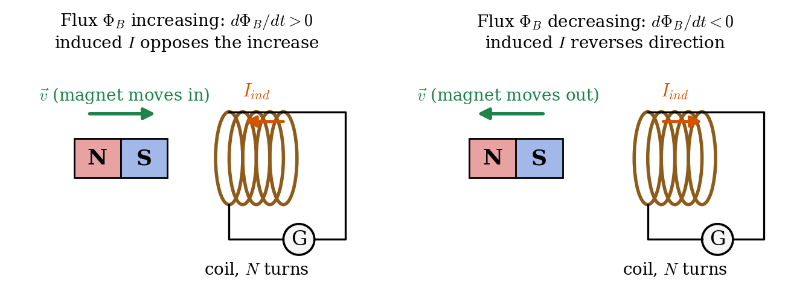
Faraday’s experiment: a moving magnet changes the flux through the coil and induces a current.
The flux through a coil can change in three ways, because $Φ_{B}=BAcosθ$: (1) by changing the magnetic field $B$, (2) by changing the area $A$ of the loop, (3) by changing the angle $θ$ between $\vec{B}$ and the loop’s normal (rotating the loop).

Consideration
- Magnetic flux through a surface: $Φ_{B}=∫\vec{B}⋅d\vec{A}$. For a uniform field and flat loop: $Φ_{B}=BAcosθ$.
- Unit of flux: weber, $1 \text{Wb}=1 {\text{T·m}}^{2}$.
- $θ$ is the angle between $\vec{B}$ and the normal to the loop (not the angle with the plane).
- The coil has $N$ identical turns, so each turn contributes the same emf and they add in series.

Statement and mathematical form
Faraday’s law: The emf induced in a circuit is equal to the negative of the rate of change of magnetic flux through the circuit.
$$ε=−N \frac{dΦ_{B}}{dt}$$
The minus sign is Lenz’s law: the induced current flows in the direction such that its own magnetic field opposes the change in flux that produced it. This is nature’s way of obeying conservation of energy.
For a constant rate of change over a time $Δt$:
$$ε=−N \frac{ΔΦ_{B}}{Δt}=−N \frac{Φ_{final}−Φ_{initial}}{Δt}$$

Derivation of motional emf (a conducting rod moving in a field)
Setup. A conducting rod of length $l$ slides with velocity $\vec{v}$ on U-shaped rails, in a uniform field $\vec{B}$ perpendicular to the plane of the rails (the circuit encloses area $A=lx$, where $x$ is the distance of the rod from the closed end).
Step 1: flux through the loop. $Φ_{B}=BA=B l x$.
Step 2: apply Faraday’s law (one turn).
$$\left|ε\right|=\frac{dΦ_{B}}{dt}=B l \frac{dx}{dt}$$
Step 3: identify $dx/dt$. It is the speed of the rod, $v$. So
$$ε=B l v$$
(Check with the force picture: charge $q$ in the rod feels $F=qvB$ along the rod. Work done per unit charge over the length $l$ is $vBl$, the same emf.)
Standard forms: $ε=−N\frac{dΦ_{B}}{dt}$, $Φ_{B}=BAcosθ$, $ε_{motional}=Blv$, $I=\frac{ε}{R}$.

Key points
- Induced emf exists only while the flux is changing. Constant flux gives zero emf, however large the flux is.
- Faster change means larger emf, because $ε∝dΦ_{B}/dt$. More turns $N$ gives proportionally larger emf.
- The minus sign (Lenz’s law) fixes the direction: induced current opposes the change.
- Unit of flux is the weber (Wb); $1 \text{V}=1 \text{Wb/s}$.

Deductions and practical concepts
- Direction using Lenz’s law. Magnet’s N pole moving toward a coil: flux increases, so the coil creates an N-face toward the magnet to push it away. Moving away: the coil creates an S-face to attract it back. Either way the coil resists the motion, so you must do work. That work becomes electrical energy.
- No change, no emf. A magnet at rest inside a coil produces nothing.
- Induced electric field. A changing flux produces an electric field whose lines form closed loops: $∮\vec{E}⋅d\vec{l}=−\frac{dΦ_{B}}{dt}$. This field is non-conservative, unlike the electrostatic field of charges (which is the subject of the rest of these notes).
- Maxwell’s equations. Faraday’s law is one of the four Maxwell equations. Together with Gauss’s law (Topic 14) it forms the foundation of electromagnetism.
- Applications. AC generators (a rotating coil changes $θ$), transformers (changing current changes $B$), induction cooktops, eddy-current brakes, microphones, wireless charging, and card readers.

2. Types of Forces

Introduction
A force is a push or a pull that can change the motion or shape of an object. In physics, all the forces we see in daily life (friction, tension, push, weight, spring force) come from only four fundamental forces of nature.

Explanation
Everyday “contact forces” such as pushing a wall are really electromagnetic forces between the atoms of your hand and the atoms of the wall. At the deepest level, only four interactions exist:
Force | Acts between | Relative strength | Range | Carrier particle
Strong nuclear | quarks, protons, neutrons | 1 (strongest) | ~${10}^{−15}$ m (nucleus size) | gluon
Electromagnetic | all charged particles | ~${10}^{−2}$ | infinite | photon
Weak nuclear | quarks and leptons (beta decay) | ~${10}^{−6}$ | ~${10}^{−18}$ m | $W^{±}$, $Z^{0}$ bosons
Gravitational | all objects with mass or energy | ~${10}^{−38}$ (weakest) | infinite | graviton (hypothetical)

Consideration: classifying forces
- Contact forces need physical touch (friction, normal force, tension). Non-contact (field) forces act across a distance through a field (gravity, electric, magnetic).
- Attractive or repulsive: gravity is always attractive. Electric and magnetic forces can be both.
- Conservative or non-conservative: gravity and the electrostatic force are conservative (work does not depend on the path). Friction is non-conservative.

Mathematical forms of the two long-range forces
Gravitational force (Newton):
$$F_{g}=G \frac{m_{1}m_{2}}{r^{2}}$$
Electric force (Coulomb):
$$F_{e}=k \frac{q_{1}q_{2}}{r^{2}}$$
Both are inverse-square laws. The difference: mass is always positive (gravity only attracts), but charge has two signs (electric force attracts and repels).

Comparison: electric versus gravitational force
For two protons separated by any distance $r$, the $r^{2}$ cancels in the ratio:
$$\frac{F_{e}}{F_{g}}=\frac{k e^{2}}{G m_{p}^{2}}=\frac{\left(8.99×{10}^{9}\right){\left(1.602×{10}^{−19}\right)}^{2}}{\left(6.674×{10}^{−11}\right){\left(1.673×{10}^{−27}\right)}^{2}}≈1.2×{10}^{36}$$
The electric force is about ${10}^{36}$ times stronger than gravity.

Key points
- Four fundamental forces: strong, electromagnetic, weak, gravitational.
- Strong force holds the nucleus together (short range). Weak force causes radioactive beta decay.
- Gravity and electromagnetism have infinite range and obey the inverse-square law.
- Electric force $≫$ gravitational force ($∼{10}^{36}$ times for two protons).

Deductions and practical concepts
- Why do we feel gravity but not the electric force of the Earth? Matter is electrically neutral (positive and negative charges cancel), so the huge electric forces cancel out. Mass never cancels, so gravity wins for large objects like planets.
- Why does the nucleus not fly apart? Protons repel each other electrically, but at nuclear distances the strong force is stronger and holds them together.
- Electromagnetism explains almost everything in chemistry and daily life: chemical bonds, friction, elasticity, light, and the normal force.
- Unification. Electricity and magnetism are two sides of one force. At very high energy, the weak and electromagnetic forces merge into the electroweak force.
- A field is how a force acts at a distance: the source creates a field in space, and the field acts on other objects. This idea leads directly to the electric field (Topic 5).

3. Characteristics of Electric Charge

Introduction
Electric charge is a basic property of matter that causes it to feel a force in an electric or magnetic field. It is as fundamental as mass. The SI unit of charge is the coulomb (C), defined as the charge that passes in one second when a current of one ampere flows: $1 \text{C}=1 \text{A·s}$.

Explanation
Matter is made of atoms. Each atom has a nucleus with positive protons and neutral neutrons, and negative electrons around it. A body is neutral when it has equal numbers of protons and electrons. If it gains electrons it becomes negatively charged; if it loses electrons, it becomes positively charged. Only electrons move in solids. Protons stay in the nucleus.

Fundamental properties of charge

(1) Two kinds of charge
Charges are of two types, named positive (+) and negative ($−$) by Benjamin Franklin. Like charges repel; unlike charges attract.

(2) Quantization of charge
Charge always comes in whole-number multiples of the elementary charge $e$:
$$Q=± n e, n=0,1,2,3,…, e=1.602×{10}^{−19} \text{C}$$
Fractional charges (quarks have $±1/3e$ and $±2/3e$) exist inside protons and neutrons but are never found free. For everyday objects $n$ is so huge that charge looks continuous. Number of electrons in 1 C: $n=\frac{1}{1.602×{10}^{−19}}≈6.24×{10}^{18}$.

(3) Conservation of charge
The total charge of an isolated system never changes. Charge is not created or destroyed; it is only transferred. In every reaction, the total charge before equals the total charge after. Example: a gamma photon (charge 0) can turn into an electron ($−e$) and a positron ($+e$), whose total is still zero.

(4) Additivity of charge
Charge is a scalar. The total charge of a system is the algebraic sum of its charges, including signs:
$$Q_{total}=q_{1}+q_{2}+q_{3}+⋯$$

(5) Charge is invariant
The charge of a body does not depend on its speed. An electron has the same charge at rest or moving near light speed, whereas mass does change with speed.

(6) Force between charges
Charges exert forces on each other that follow Coulomb’s law (Topic 4), and the force is stronger the closer they are.

(7) Conductors, insulators and semiconductors
- Conductors (metals) contain free electrons, so charge flows easily and spreads over the surface.
- Insulators (rubber, glass, plastic) hold their electrons tightly, so added charge stays where it is placed.
- Semiconductors (silicon, germanium) lie in between.

Methods of charging
Method | How it works | Result
Friction | Two different insulators are rubbed; electrons transfer from one to the other. | Equal and opposite charges.
Conduction | A charged body touches a neutral conductor; charge flows across. | Same sign as the charged body.
Induction | A charged body is brought near (without touching) a conductor, which is earthed momentarily and then the earth connection is removed. | Opposite sign to the charged body.
Polarization: an insulator brought near a charged body does not gain free charge, but its atoms slightly shift charge to one side. This is why a charged comb attracts small pieces of paper: the nearer, opposite charge is stronger than the farther, same-sign charge, so the net force is attractive.

Charge densities (for continuous charge distributions)
When charge is spread over a body, we describe it by a density:
$$λ=\frac{dq}{dl} \left(\text{C/m}\right), σ=\frac{dq}{dA} \left({\text{C/m}}^{2}\right), ρ=\frac{dq}{dV} \left({\text{C/m}}^{3}\right)$$
So a small element carries $dq=λ dl$ (line), $dq=σ dA$ (surface) or $dq=ρ dV$ (volume). For uniform distributions, $λ=Q/L$, $σ=Q/A$, $ρ=Q/V$.

Key points
- Two types: positive and negative. Like repel, unlike attract.
- Quantized: $Q=ne$, $e=1.602×{10}^{−19}$ C. Conserved in every process. Additive (a scalar). Invariant with speed.
- Electron: $−e$, mass $9.11×{10}^{−31}$ kg. Proton: $+e$, mass $1.673×{10}^{−27}$ kg. Neutron: 0.
- Charging by friction, conduction (same sign) and induction (opposite sign).

Deductions and practical concepts
- Charging means moving electrons. A body that loses $n$ electrons has charge $+ne$. Even a charge of 1 $μ$C involves about $6×{10}^{12}$ electrons, which is tiny compared with the $∼{10}^{23}$ in a small solid.
- Why are charges of 1 C rare? 1 C is a huge amount of charge. Static electricity involves nC to $μ$C. Lightning carries tens of coulombs.
- Charge on a conductor lives on the outer surface, because like charges repel and move as far apart as possible (proved with Gauss’s law, Topic 15).
- Earthing (grounding) gives excess charge a path to flow to Earth, which is a huge reservoir that stays neutral. Used in appliances and to protect buildings (lightning rods).
- Applications: photocopiers and laser printers, electrostatic precipitators (remove smoke particles), spray painting, inkjet printers, and the hazards of sparks near fuel (aircraft are earthed before refuelling).

4. Coulomb’s Law

Introduction
In 1785 the French physicist Charles-Augustin de Coulomb measured the force between small charged spheres using a torsion balance. His result, Coulomb’s law, is the fundamental law of electrostatics (the study of charges at rest).

Explanation
Two charges push or pull on each other. The force gets bigger if the charges are bigger, and it gets weaker quickly as they move apart. Specifically it depends on the product of the charges and on the square of the distance, so doubling the distance makes the force four times weaker.
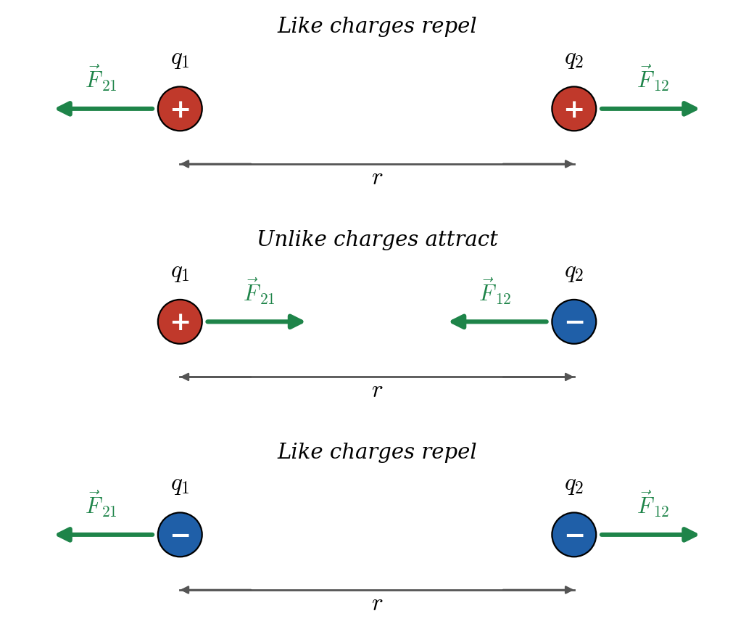
Forces between two point charges. The forces are equal and opposite (Newton’s third law) and act along the line joining the charges.

Consideration (conditions of the law)
- The charges must be point charges (size much smaller than the distance between them), or spheres whose charge is spread symmetrically, in which case $r$ is measured centre to centre.
- The charges are at rest (or moving very slowly) relative to each other.
- The law as written is for charges in vacuum (or air). In another medium the force is reduced by the dielectric constant $κ$ (relative permittivity $ε_{r}$).

Statement
Coulomb’s law: The electrostatic force between two point charges is directly proportional to the product of the magnitudes of the charges and inversely proportional to the square of the distance between them, and it acts along the line joining them.

Mathematical form
Magnitude (scalar form):
$$F=k \frac{\left|q_{1}\right|\left|q_{2}\right|}{r^{2}}, k=\frac{1}{4πε_{0}}=8.99×{10}^{9} {\text{N·m}}^{2}/{\text{C}}^{2}$$
Here $F$ is the force in newtons, $q_{1},q_{2}$ the charges in coulombs, $r$ the separation in metres, and $ε_{0}=8.854×{10}^{−12} {\text{C}}^{2}/{\text{N·m}}^{2}$. The constant $k$ appears because we chose SI units; it is the force between two 1 C charges 1 m apart in vacuum.
Vector form. To give the direction as well, let ${\hat{r}}_{12}$ be the unit vector pointing from charge $q_{1}$ toward charge $q_{2}$. Then the force on $q_{2}$ due to $q_{1}$ is
$${\vec{F}}_{12}=k \frac{q_{1}q_{2}}{r^{2}} {\hat{r}}_{12}=\frac{1}{4πε_{0}}\frac{q_{1}q_{2}}{{\left|{\vec{r}}_{2}−{\vec{r}}_{1}\right|}^{3}} \left({\vec{r}}_{2}−{\vec{r}}_{1}\right)$$
If $q_{1}q_{2}>0$ (like charges) the force on $q_{2}$ points along ${\hat{r}}_{12}$ (away from $q_{1}$): repulsion. If $q_{1}q_{2}<0$ it points opposite: attraction.
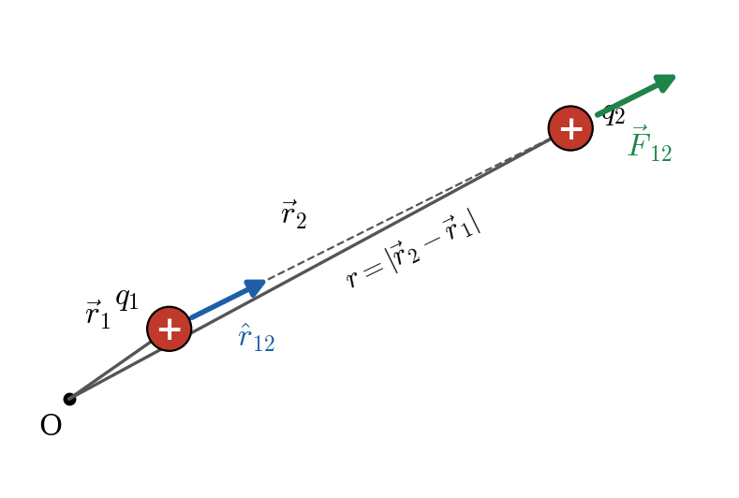
Vector form of Coulomb’s law: position vectors ${\vec{r}}_{1}$, ${\vec{r}}_{2}$ and the unit vector ${\hat{r}}_{12}$.
Newton’s third law: ${\vec{F}}_{21}=−{\vec{F}}_{12}$.
Superposition principle. With many charges, the net force on one charge is the vector sum of the forces due to each of the others, taken one at a time, because each pair acts independently:
Fnet=F1+F2+⋯+Fn=i​ k q qiri2 ri
In a medium:
$$F_{medium}=\frac{F_{vacuum}}{ε_{r}}=\frac{1}{4πε_{0}ε_{r}}\frac{q_{1}q_{2}}{r^{2}}$$
with $ε_{r}=1$ (vacuum, approx. air), about 80 (water), so two charges in water attract or repel about 80 times less.

Key points
- $F=k\frac{q_{1}q_{2}}{r^{2}}$: inverse-square law, $F∝q_{1}q_{2}$, $F∝1/r^{2}$.
- Acts along the line joining the charges; equal and opposite on the two charges.
- Like charges repel ($F>0$ in the formula), unlike charges attract ($F<0$).
- Forces from several charges add as vectors (superposition).
- $k=9×{10}^{9} {\text{N·m}}^{2}/{\text{C}}^{2}$, $ε_{0}=8.854×{10}^{−12} {\text{C}}^{2}/{\text{N·m}}^{2}$.

Deductions and practical concepts
- Dependence on distance. Double $r$ gives $F/4$. Half $r$ gives $4F$. Triple $r$ gives $F/9$.
- Dependence on charge. Doubling one charge doubles $F$. Doubling both gives $4F$.
- Definition of the coulomb. 1 C is the charge that exerts a force of $9×{10}^{9}$ N on an equal charge 1 m away. This enormous force shows why 1 C is a huge charge.
- Strength. Between an electron and proton in hydrogen ($r=5.29×{10}^{−11}$ m) the force is $F=\frac{ke^{2}}{r^{2}}≈8.2×{10}^{−8}$ N: tiny in absolute terms, but huge on the scale of an electron.
- Shell theorem. A uniformly charged spherical shell acts on outside charges as if all its charge were at its centre. Inside the shell, the net force is zero.
- Same form as gravity. Both laws are inverse-square. Because of that, Gauss’s law applies to both (Topic 14).
- Applications. Electrostatic precipitators, laser printers, atomic and molecular structure (binding of atoms), ionic crystals like NaCl.
- Common mistake. The signs of the charges are used only to decide the direction; when computing magnitude use $\left|q_{1}\right|\left|q_{2}\right|$.

5. Electric Field

Introduction
Coulomb’s law says charges act on each other across empty space. To explain how this happens, we say that every charge creates an electric field in the space around it, and any other charge placed in that field feels a force from the field. The field is what carries the “message” from one charge to the other.

Explanation
Imagine a charge $Q$ (the source). Place a tiny positive test charge $q_{0}$ at a point $P$ near it. The test charge feels a force $\vec{F}$. The force per unit of test charge tells us how strong the field of $Q$ is at $P$. The test charge must be very small so that it does not disturb the source.

Definition
The electric field at a point is the force per unit positive test charge placed there:
$$\vec{E}=\lim_{q_{0}→0}\frac{\vec{F}}{q_{0}}$$
Unit: newton per coulomb (N/C), which equals volt per metre (V/m). It is a vector quantity: its direction is the direction of the force on a positive test charge.

Derivation: field of a point charge
Step 1. Put test charge $q_{0}$ at distance $r$ from the source $Q$. Coulomb’s law gives the force on $q_{0}$:
$$F=k\frac{Qq_{0}}{r^{2}}$$
Step 2. Divide by $q_{0}$:
$$E=\frac{F}{q_{0}}=k\frac{Q}{r^{2}}$$
Step 3. Add the direction ($\hat{r}$ points from the source outward):
$$\vec{E}=k \frac{Q}{r^{2}} \hat{r}=\frac{1}{4πε_{0}}\frac{Q}{r^{2}} \hat{r}$$
For $Q>0$ the field points away from the charge; for $Q<0$ it points toward it.

Force on a charge in a field
Once the field at a point is known, the force on any charge $q$ placed there is
$$\vec{F}=q \vec{E}$$
so a positive charge moves along $\vec{E}$, a negative charge opposite to $\vec{E}$.

Superposition and continuous charge
Group of point charges: Enet=i​Ei=i​kqiri2ri (vector sum).
Continuous charge: split the body into tiny elements $dq$, find the field $d\vec{E}$ of each as a point charge and add them by integration:
$$\vec{E}=∫d\vec{E}=∫k \frac{dq}{r^{2}} \hat{r}, dq=λ dl \text{ or } σ dA \text{ or } ρ dV$$
This is the method used in Topics 10 to 13.

Key points
- $\vec{E}=\vec{F}/q_{0}$ (vector, N/C = V/m). Point charge: $E=kQ/r^{2}$.
- $\vec{F}=q\vec{E}$. Positive charge: force along $\vec{E}$. Negative charge: opposite to $\vec{E}$.
- $E$ does not depend on the test charge; it depends only on the source charges and position.
- Superposition: add fields as vectors.

Deductions and practical concepts
- The field exists even if no test charge is present. It is a property of the space around the source.
- Inverse-square decrease. $E∝1/r^{2}$. At $2r$ the field is a quarter.
- Inside a uniform field, a charge $q$ of mass $m$ has constant acceleration $a=\frac{qE}{m}$. It moves on a straight line (if released from rest) or a parabola (if launched at an angle), exactly like a projectile under gravity. This is used in oscilloscope and TV tubes, inkjet printers and particle accelerators.
- Why a test charge must be small. A large test charge would push the source charges around and change the very field we want to measure.
- Field is zero at a point where the vector sum of all fields is zero (for two equal like charges, at the midpoint).
- Direction check. Draw the field of each positive charge away and of each negative charge toward the point before adding.
- Millikan’s oil-drop experiment balanced $qE=mg$ to measure the elementary charge $e$.

6. Characteristics of Electric Field Lines

Introduction
Faraday introduced electric field lines (also called lines of force) as a way to draw an electric field. They are imaginary lines whose tangent at every point gives the direction of $\vec{E}$ there.

Explanation
Picture a tiny positive charge released in the field. The curve it would follow is the field line. By drawing many such lines we can see the shape and strength of the whole field at a glance.
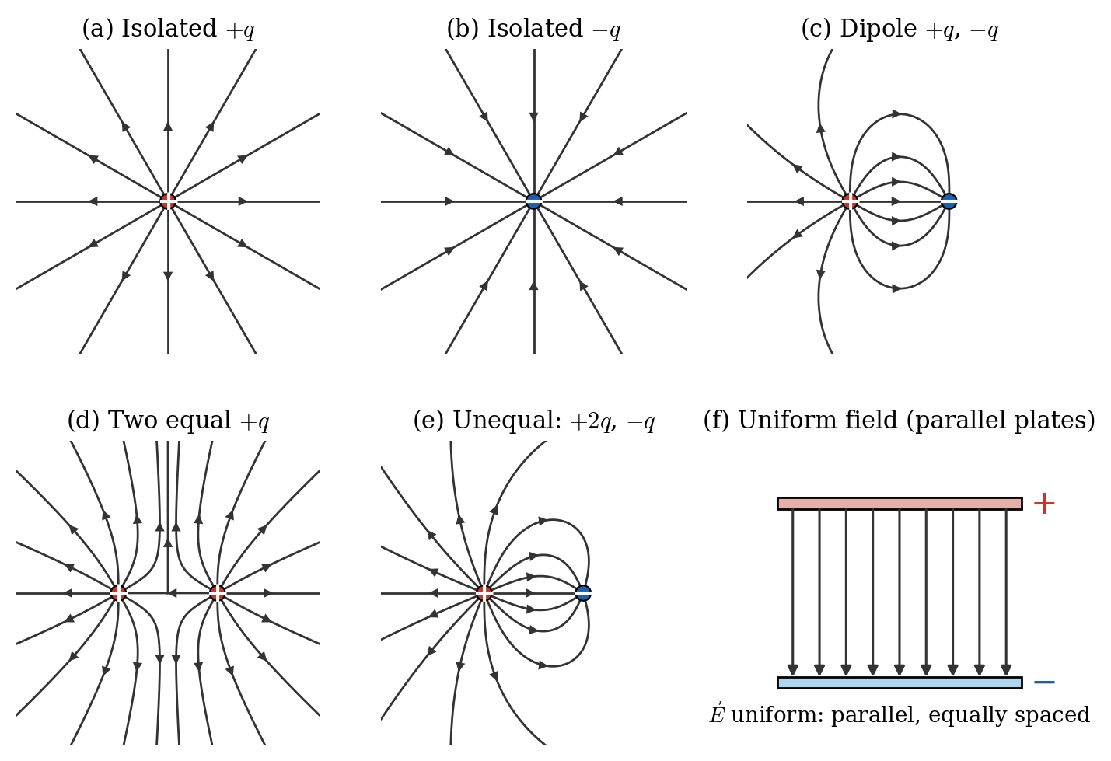
Electric field lines: (a) isolated positive charge, (b) isolated negative charge, (c) dipole, (d) two equal positive charges, (e) unequal charges, (f) uniform field between parallel plates.

Properties (characteristics) of field lines
- Field lines start on positive charges and end on negative charges (or go to/come from infinity for isolated charges).
- The tangent to a field line at any point gives the direction of $\vec{E}$ at that point.
- The density of lines (number per unit area perpendicular to them) is proportional to the magnitude of $E$. Close lines mean a strong field; spread-out lines mean a weak field.
- Field lines never cross. If two lines crossed, $\vec{E}$ would have two directions at one point, which is impossible.
- Field lines are continuous curves with no breaks, except where they begin or end on charge.
- Field lines are perpendicular to the surface of a conductor at equilibrium (the field has no component along the surface, or charge would move).
- In electrostatics, field lines never form closed loops. This follows from the fact that the electrostatic field is conservative.
- The number of lines leaving (or entering) a charge is proportional to its magnitude. A $+2q$ charge has twice as many lines as a $−q$ charge.
- For a uniform field the lines are parallel and equally spaced.
- Faraday’s picture: lines behave as if they are stretched along their length (contract) and push sideways on each other (repel). This explains attraction between unlike charges and repulsion between like charges.
- There are no field lines inside a conductor (the field is zero there).
- Lines are only a visual aid; the field exists everywhere, not only on the lines.

Key points
- Start on $+$, end on $−$. Tangent = direction of $\vec{E}$. Density $∝E$.
- Never cross, never form closed loops (electrostatics), meet conductors at 90°.
- Uniform field: parallel, equally spaced lines. Isolated charge: radial lines.

Deductions and practical concepts
- Why do lines become denser near a charge? The field varies as $1/r^{2}$, and the lines spread out over a sphere of area $4πr^{2}$. The same number of lines over a larger area gives a smaller density, matching $E∝1/r^{2}$.
- Neutral point. Between two equal like charges there is a point where the lines “separate” and $E=0$ (diagram (d)). No line passes through such a point.
- Lines at conductors. Sharp points on conductors have crowded lines, which means a very strong field. This is why lightning rods have pointed tips and why sparks jump from sharp points (corona discharge).
- Direction versus path. A charge does not necessarily travel along a line of force. The line gives the direction of force, but a moving charge also has inertia. Only a charge starting from rest in a straight-line field follows the line.
- Charge shielding. A closed metal box has no field inside: this is the Faraday cage, which protects against lightning and electromagnetic interference.

7. Electric Flux

Introduction
Electric flux measures how much of the electric field passes through a given surface. It is a central idea in Gauss’s law.

Explanation
Compare the field to wind blowing, and the surface to a window. If the window faces the wind squarely, the most air passes through. If it is tilted, less air passes. If the window is edge-on to the wind, no air passes. Flux works the same way: it counts the number of field lines passing through the surface.
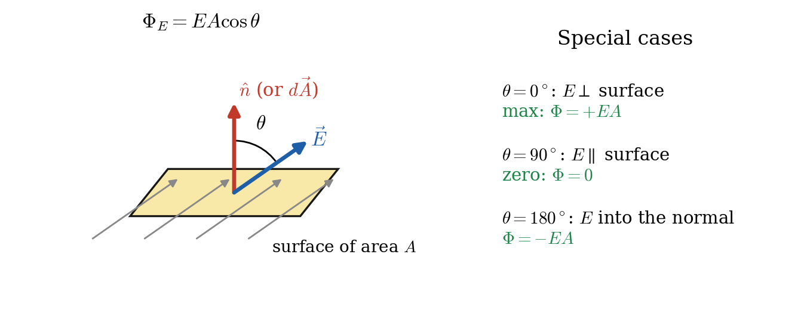
Electric flux through a flat surface: $θ$ is the angle between $\vec{E}$ and the normal $\hat{n}$ (area vector).

Consideration
- The area vector $d\vec{A}=dA \hat{n}$ has magnitude equal to the area and direction perpendicular (normal) to the surface.
- For a closed surface, $\hat{n}$ is chosen to point outward. Field lines leaving give positive flux, and lines entering give negative flux.
- $θ$ is the angle between $\vec{E}$ and $\hat{n}$ (not between $\vec{E}$ and the surface).

Derivation (definition) of flux
Uniform field, flat surface. Only the component of $\vec{E}$ perpendicular to the surface passes through it, $E_{⊥}=Ecosθ$. Multiply by the area:
$$Φ_{E}=Ecosθ⋅A=\vec{E}⋅\vec{A}$$
General case (non-uniform field, curved surface). Divide the surface into tiny patches $d\vec{A}$ so that each is flat and $\vec{E}$ is nearly constant on it. Add up the contributions:
$$Φ_{E}=∫\vec{E}⋅d\vec{A}=∫E cosθ dA$$
Closed surface:
$$Φ_{E}=∮\vec{E}⋅d\vec{A}$$
where the circle on the integral means “over the whole closed surface”.
Standard form: $Φ_{E}=\vec{E}⋅\vec{A}=EAcosθ$ (uniform field, flat surface); $Φ_{E}=∮\vec{E}⋅d\vec{A}$ (closed surface). Unit: ${\text{N·m}}^{2}/\text{C}$.

Flux of a point charge through a sphere
Put charge $q$ at the centre of an imaginary sphere of radius $r$. At every point of the sphere, $\vec{E}$ points radially outward, parallel to $d\vec{A}$ (so $cosθ=1$) and has the same magnitude $E=kq/r^{2}$. Therefore
$$Φ_{E}=∮E dA=E∮dA=\frac{kq}{r^{2}} \left(4πr^{2}\right)=4πk q=\frac{q}{ε_{0}}$$
Notice that $r$ cancels: the flux does not depend on the size of the sphere. This is the seed of Gauss’s law.

Key points
- $Φ_{E}=∮\vec{E}⋅d\vec{A}=EAcosθ$; unit N·m²/C; scalar quantity.
- $θ=0^{∘}$: maximum flux. $θ={90}^{∘}$: zero. $θ={180}^{∘}$: negative (inward).
- Outward flux is positive and inward flux is negative.
- Flux through any closed surface around a charge $q$ is $q/ε_{0}$.

Deductions and practical concepts
- Flux is a scalar, though $\vec{E}$ and $d\vec{A}$ are vectors, because it comes from a dot product.
- A uniform field gives zero net flux through any closed surface. Whatever enters on one side leaves on the other, so the inward and outward contributions cancel.
- Independence of shape. The flux $q/ε_{0}$ is the same for a sphere, cube or any shape enclosing the charge, because the same lines pass through them all.
- Cube example. A charge $q$ at the centre of a cube: by symmetry each of the 6 faces carries $\frac{1}{6}\frac{q}{ε_{0}}$.
- Flux counts lines. The more field lines pass through, the larger the flux. This links to the idea that the number of lines is proportional to charge.
- Flux through a surface with a charge outside is zero if the surface is closed (lines going in = lines coming out).
- Dimensional check. $\left[E\right]\left[A\right]=\frac{\text{N}}{\text{C}}{\text{m}}^{2}={\text{N·m}}^{2}/\text{C}$.

8. Electric Dipole

Introduction
An electric dipole is a pair of equal and opposite point charges, $+q$ and $−q$, separated by a small distance $2a$. Overall the dipole is neutral (net charge zero), but because the two charges are in different places, it produces a field and responds to fields in its own special way.

Explanation
The charges are slightly apart, so their fields do not cancel completely. Close to the dipole the field is strong and complicated. Far away, the two fields almost cancel, so the dipole’s field is weaker than that of a single charge, dying out faster with distance.
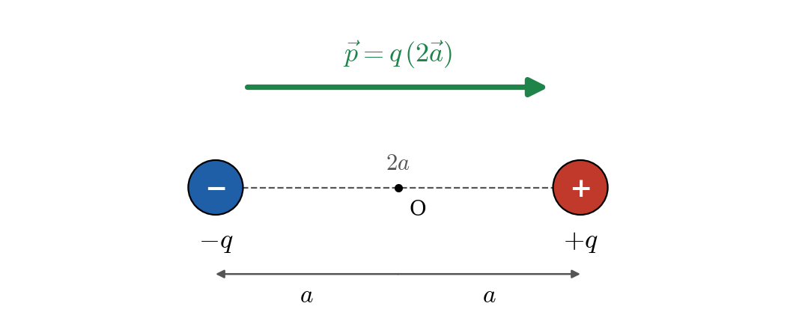
An electric dipole: charges $+q$ and $−q$ separated by $2a$; the dipole moment $\vec{p}$ points from $−q$ to $+q$.

Consideration
- Separation between charges is $2a$ (some books use $d$ or $l$). The midpoint $O$ is the centre of the dipole.
- The line through both charges is the axis. The line through $O$ perpendicular to the axis is the equatorial line.
- A dipole is called ideal (point dipole) when $2a→0$ and $q→∞$ such that $p=q\left(2a\right)$ stays finite.

Key points
- Dipole = $+q$ and $−q$ separated by $2a$. Net charge $=0$.
- Directional quantity: the dipole moment $\vec{p}$ points from $−q$ to $+q$.
- Far-field falls as $1/r^{3}$ (faster than the $1/r^{2}$ of a single charge).

Deductions and practical concepts
- Polar molecules are natural dipoles. In water (H$​_{2}$O) the O atom attracts electrons, so it is slightly negative and the H atoms slightly positive. Other polar molecules: HCl, NH$​_{3}$.
- Non-polar molecules (O$​_{2}$, N$​_{2}$, CH$​_{4}$) have no permanent dipole, but an external field can induce one by shifting the electron cloud.
- Why water dissolves salts. Its dipoles surround the Na$​^{+}$ and Cl$​^{−}$ ions and reduce their attraction.
- Microwave ovens use a rapidly alternating field to flip water dipoles back and forth, producing heat by friction between molecules.
- Antennas work as oscillating dipoles that radiate electromagnetic waves.

9. Electric Dipole Moment

Introduction
The electric dipole moment $\vec{p}$ is the quantity that measures the strength and orientation of a dipole.

Definition and standard form
$$\vec{p}=q \left(2\vec{a}\right) \text{magnitude: }p=q⋅2a$$
where $2\vec{a}$ is the displacement vector from the negative charge to the positive charge. Direction: from $−q$ to $+q$. Unit: coulomb-metre (C·m). A common unit for molecules is the debye: $1 \text{D}=3.34×{10}^{−30} \text{C·m}$.
Molecule | Dipole moment
H$​_{2}$O | $6.2×{10}^{−30}$ C·m (1.85 D)
HCl | $3.6×{10}^{−30}$ C·m (1.08 D)

Behaviour of a dipole in an external uniform field
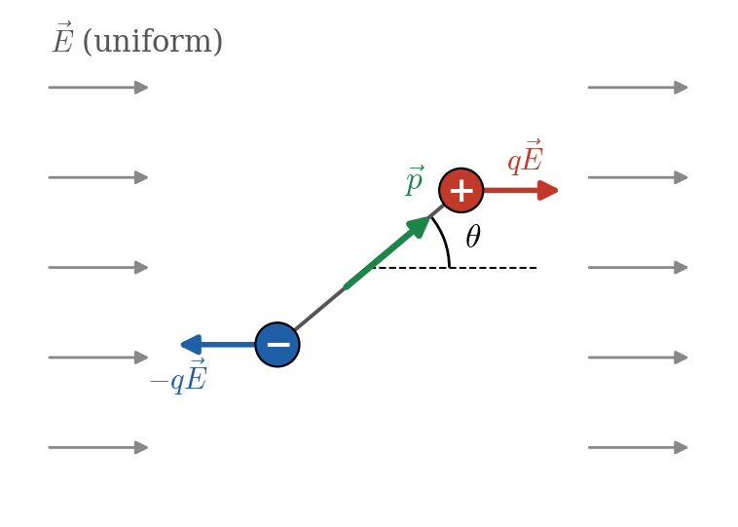
A dipole in a uniform field: equal and opposite forces form a couple that rotates it toward alignment with $\vec{E}$.
Net force. The force on $+q$ is $q\vec{E}$ and on $−q$ is $−q\vec{E}$. These cancel, so the net force is zero in a uniform field.
Torque. The two forces are equal, opposite, and along different lines, forming a couple. Each force $qE$ has a perpendicular arm $asinθ$ about the centre, where $θ$ is the angle between $\vec{p}$ and $\vec{E}$:
$$τ=qE \left(asinθ\right)+qE \left(asinθ\right)=q \left(2a\right) Esinθ=pEsinθ$$
Vector form:
$$\vec{τ}=\vec{p}×\vec{E}$$
The torque tries to rotate the dipole to line up with $\vec{E}$.
Potential energy of the dipole (work done in rotating it from $θ_{0}={90}^{∘}$ to $θ$):
$$U=− pEcosθ=− \vec{p}⋅\vec{E}$$
Orientation | $τ$ | $U$ | Equilibrium
$θ=0^{∘}$ ($\vec{p}∥\vec{E}$) | 0 | $−pE$ (minimum) | Stable
$θ={90}^{∘}$ | $pE$ (maximum) | 0 | none
$θ={180}^{∘}$ ($\vec{p}$ opposite $\vec{E}$) | 0 | $+pE$ (maximum) | Unstable

Key points
- $\vec{p}=q\left(2\vec{a}\right)$, unit C·m, direction $−q→+q$.
- Uniform field: net force $=0$; torque $\vec{τ}=\vec{p}×\vec{E}$, $τ=pEsinθ$; $U=−\vec{p}⋅\vec{E}$.
- Stable equilibrium at $θ=0^{∘}$, unstable at ${180}^{∘}$.

Deductions and practical concepts
- Maximum torque is $pE$, at $θ={90}^{∘}$.
- Non-uniform field. The forces on $+q$ and $−q$ no longer cancel, so the dipole feels a net force as well as a torque. This is why a charged comb attracts neutral paper: it induces a dipole in the paper, and the nearer end feels the stronger force.
- Alignment of molecules. In a dielectric placed in a field, molecular dipoles line up. This is called polarization and it reduces the field inside the material.
- Small oscillations. For small $θ$, $τ≈−pEθ$, which gives simple harmonic motion with $T=2π\sqrt{I/\left(pE\right)}$, where $I$ is the moment of inertia of the dipole.
- Dipole moment adds as a vector for groups of charges: $\vec{p}=∑q_{i}{\vec{r}}_{i}$.

10. Electric Field Due to an Electric Dipole (Derivation)

Introduction
We find the field of a dipole at two special locations: on the axis (axial point) and on the equatorial line (broadside point). Then we state the general result for any point.

Consideration (setup and assumptions)
- Dipole made of $+q$ at $x=+a$ and $−q$ at $x=−a$ on the $x$-axis, centre $O$ at the origin, so $p=q\left(2a\right)$ and $\vec{p}$ points in the $+x$ direction.
- Point $P$ is at distance $r$ from the centre $O$.
- We use $k=\frac{1}{4πε_{0}}$ and the superposition principle: $\vec{E}={\vec{E}}_{+}+{\vec{E}}_{−}$.
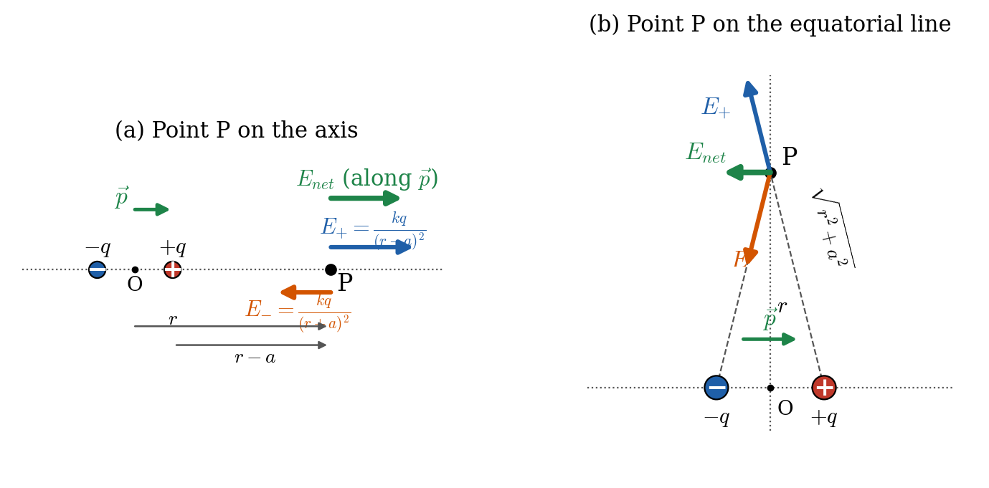
Field of a dipole at (a) an axial point and (b) an equatorial point.

Case 1: Field at an axial point (on the axis, distance $r$ from the centre, $r>a$)
Step 1: distances. $P$ is at $r−a$ from $+q$ and $r+a$ from $−q$.
Step 2: field magnitudes and directions.
$$E_{+}=\frac{kq}{{\left(r−a\right)}^{2}} \left(\text{along }+x, \text{away from }+q\right), E_{−}=\frac{kq}{{\left(r+a\right)}^{2}} \left(\text{along }−x, \text{toward }−q\right)$$
Step 3: the nearer charge wins, so the net field points along $+x$ (the direction of $\vec{p}$):
$$E_{axial}=E_{+}−E_{−}=kq\left[\frac{1}{{\left(r−a\right)}^{2}}−\frac{1}{{\left(r+a\right)}^{2}}\right]$$
Step 4: common denominator.
$$E_{axial}=kq \frac{{\left(r+a\right)}^{2}−{\left(r−a\right)}^{2}}{{\left(r−a\right)}^{2}{\left(r+a\right)}^{2}}=kq \frac{4ar}{{\left(r^{2}−a^{2}\right)}^{2}}$$
Step 5: replace $q⋅2a$ with $p$.
$$E_{axial}=\frac{k \left(2a q\right)\left(2r\right)}{{\left(r^{2}−a^{2}\right)}^{2}}=\frac{2k p r}{{\left(r^{2}−a^{2}\right)}^{2}}$$
Step 6: far-field approximation ($r≫a$), so $r^{2}−a^{2}≈r^{2}$:
$$E_{axial}=\frac{2kp}{r^{3}}=\frac{1}{4πε_{0}}\frac{2p}{r^{3}} \left(\text{direction: along }\vec{p}\right)$$

Case 2: Field at an equatorial point (on the perpendicular bisector, distance $r$ from the centre)
Step 1: distance. $P$ is at the same distance from both charges, $d=\sqrt{r^{2}+a^{2}}$.
Step 2: magnitudes. The two fields have equal magnitude:
$$E_{+}=E_{−}=\frac{kq}{r^{2}+a^{2}}$$
${\vec{E}}_{+}$ points away from $+q$ and ${\vec{E}}_{−}$ points toward $−q$.
Step 3: resolve into components. Let each field make angle $α$ with the line parallel to the axis, where $cosα=\frac{a}{\sqrt{r^{2}+a^{2}}}$. The components perpendicular to the axis (along $OP$) are equal and opposite, so they cancel. The components parallel to the axis both point in the $−x$ direction (opposite to $\vec{p}$), so they add:
$$E_{equatorial}=E_{+}cosα+E_{−}cosα=2⋅\frac{kq}{r^{2}+a^{2}}⋅\frac{a}{\sqrt{r^{2}+a^{2}}}$$
Step 4: simplify.
$$E_{equatorial}=\frac{k q \left(2a\right)}{{\left(r^{2}+a^{2}\right)}^{3/2}}=\frac{k p}{{\left(r^{2}+a^{2}\right)}^{3/2}}$$
Step 5: far-field approximation ($r≫a$), so ${\left(r^{2}+a^{2}\right)}^{3/2}≈r^{3}$:
$$E_{equatorial}=\frac{kp}{r^{3}}=\frac{1}{4πε_{0}}\frac{p}{r^{3}} \left(\text{direction: opposite to }\vec{p}\right)$$

Field at a general point (result, far field)
At a point at distance $r$ from the centre, making angle $θ$ with the dipole axis ($r≫a$), the field has radial and tangential components:
$$E_{r}=\frac{2kpcosθ}{r^{3}}, E_{θ}=\frac{kpsinθ}{r^{3}}, E=\frac{kp}{r^{3}}\sqrt{1+3\cos^{2}θ}$$
Putting $θ=0^{∘}$ gives $E=2kp/r^{3}$ (axial) and $θ={90}^{∘}$ gives $E=kp/r^{3}$ (equatorial), matching the two cases above.

Key points
- Axial: $E=\frac{2kp r}{{\left(r^{2}−a^{2}\right)}^{2}}≈\frac{2kp}{r^{3}}$, direction along $\vec{p}$.
- Equatorial: $E=\frac{kp}{{\left(r^{2}+a^{2}\right)}^{3/2}}≈\frac{kp}{r^{3}}$, direction opposite to $\vec{p}$.
- $E_{axial}=2 E_{equatorial}$ for the same $r$ (far field).
- Both fall as $1/r^{3}$.

Deductions and practical concepts
- Why $1/r^{3}$? The two charges produce fields of nearly equal size and opposite sign. They almost cancel, leaving only the small difference, which falls off faster than a single charge’s field.
- Axial is twice equatorial because on the axis the two fields are along the same line (nearer charge dominates), but on the equator they are at an angle and the perpendicular parts cancel.
- Directions. On the axis (outside the charges) $\vec{E}$ points along $\vec{p}$. On the equatorial line $\vec{E}$ points from the $+q$ side toward the $−q$ side, which is opposite to $\vec{p}$. You can check this on the field-line picture of a dipole (Topic 6, diagram (c)).
- Limit $a→0$. The exact formulas reduce to the point-dipole results, because $\left(r^{2}−a^{2}\right)→r^{2}$.
- Only $p=q⋅2a$ matters far away, not $q$ and $a$ separately. This is why the dipole moment is the natural quantity to use.
- Applications: field of polar molecules, intermolecular (van der Waals-type) forces, dielectric behaviour, the radiation field of a dipole antenna.

11. Electric Field on the Axis of a Ring of Charge

Introduction
A uniformly charged ring is the simplest continuous charge distribution with a useful answer, and it is the building block for the disk (Topic 12).

Consideration (setup and assumptions)
- A thin ring of radius $R$ carries total charge $Q$ spread uniformly. The ring lies in a plane, centre $C$.
- The point $P$ is on the axis through the centre and perpendicular to the plane, at distance $x$ from the centre.
- Each small element of charge $dq$ is the same distance $r=\sqrt{x^{2}+R^{2}}$ from $P$, because every point on the ring is at distance $R$ from the axis.
- Use symmetry: perpendicular components from opposite elements cancel.
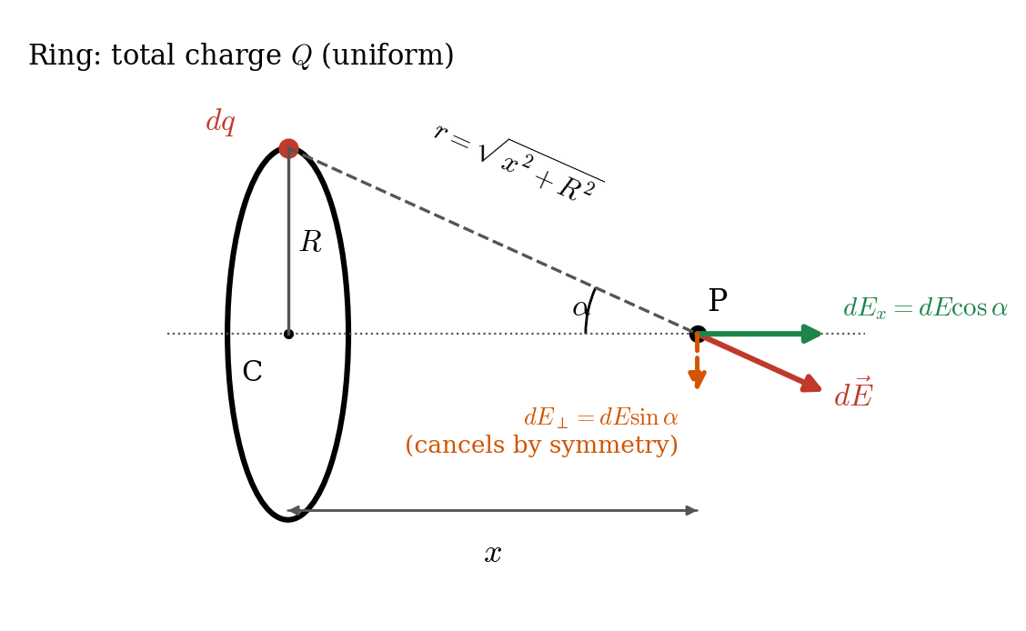
Ring of charge: geometry for the field at an axial point P.

Derivation
Step 1: field of one element. The element $dq$ produces a field of magnitude
$$dE=k\frac{dq}{r^{2}}=k\frac{dq}{x^{2}+R^{2}}$$
pointing along the line from $dq$ through $P$ (away from the element, if $Q>0$).
Step 2: resolve into components. Let $α$ be the angle between this line and the axis, so $cosα=\frac{x}{r}$. Components:
$$dE_{x}=dEcosα \left(\text{along the axis}\right), dE_{⊥}=dEsinα \left(\text{perpendicular to the axis}\right)$$
Step 3: use symmetry. For each element there is an element exactly opposite on the ring whose $dE_{⊥}$ is equal and opposite. So all perpendicular components cancel, and only $dE_{x}$ survives:
$$E=∫dE_{x}=∫dEcosα$$
Step 4: substitute.
$$E=∫k\frac{dq}{x^{2}+R^{2}}⋅\frac{x}{\sqrt{x^{2}+R^{2}}}=\frac{k x}{{\left(x^{2}+R^{2}\right)}^{3/2}}∫dq$$
The factors $x$, $R$ are constants for all elements, so they come out of the integral. Step 5: integrate. $∫dq=Q$.
$$E=\frac{1}{4πε_{0}}\frac{Q x}{{\left(x^{2}+R^{2}\right)}^{3/2}} \left(\text{along the axis, away from the ring if }Q>0\right)$$

Key points
- $E=\frac{kQx}{{\left(x^{2}+R^{2}\right)}^{3/2}}$ on the axis, directed along the axis.
- Perpendicular components cancel by symmetry; only axial components add.
- $E=0$ at the centre ($x=0$). Far away ($x≫R$) it becomes $kQ/x^{2}$.
- Maximum field at $x=\frac{R}{\sqrt{2}}$.

Deductions and practical concepts
- At the centre ($x=0$): $E=0$. Every element is cancelled by the opposite one, so the field is zero, though the potential is not zero.
- Far away ($x≫R$): ${\left(x^{2}+R^{2}\right)}^{3/2}≈x^{3}$, so $E→\frac{kQ}{x^{2}}$. From far away the ring looks like a point charge $Q$.
- Maximum field. Setting $\frac{dE}{dx}=0$:
$$\frac{d}{dx}\left[\frac{x}{{\left(x^{2}+R^{2}\right)}^{3/2}}\right]=\frac{R^{2}−2x^{2}}{{\left(x^{2}+R^{2}\right)}^{5/2}}=0 ⇒ x=\frac{R}{\sqrt{2}}$$
$$E_{max}=\frac{2kQ}{3\sqrt{3} R^{2}}≈0.385 \frac{kQ}{R^{2}}$$
- Near the centre ($x≪R$): $E≈\frac{kQx}{R^{3}}$, linear in $x$. A small charge $−q$ released on the axis near the centre of a positive ring feels a restoring force proportional to displacement, so it oscillates in simple harmonic motion with $ω=\sqrt{\frac{kQq}{mR^{3}}}$.
- Direction. For $Q>0$ the field is away from the ring on both sides (the sign of $x$ gives the direction); for $Q<0$ it is toward the ring.
- Applications: model for a charged rim, ion traps and electron-beam lenses. Mathematically, the ring is the building block for disks, spheres and cylinders.

12. Electric Field on the Axis of a Charged Disk

Introduction
We treat the disk as a collection of thin concentric rings and add up their fields using the ring result from Topic 11.

Consideration (setup and assumptions)
- A flat circular disk of radius $R$ with uniform surface charge density $σ=\frac{Q}{πR^{2}}$.
- Point $P$ lies on the axis at distance $x$ from the centre.
- Choose a thin ring of radius $r$ and width $dr$ ($0<r<R$). Its area is $dA=2πr dr$, so its charge is $dq=σ dA=σ \left(2πr dr\right)$.
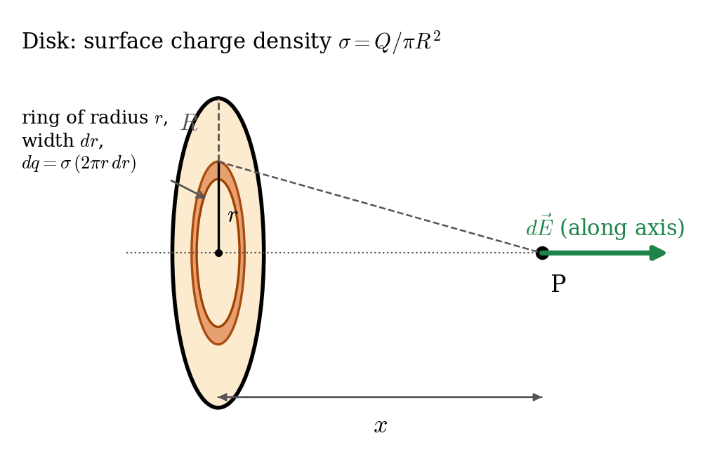
Disk of charge: the disk is divided into thin rings of radius $r$ and width $dr$.

Derivation
Step 1: field of one ring. From Topic 11 (replace $R→r$, $Q→dq$):
$$dE=\frac{k x dq}{{\left(x^{2}+r^{2}\right)}^{3/2}}=\frac{k x σ \left(2πr dr\right)}{{\left(x^{2}+r^{2}\right)}^{3/2}}$$
All rings produce fields along the same axis, so we add the magnitudes.
Step 2: integrate over the disk, $r=0$ to $R$.
$$E=2πk σ x\int_{0}^{R}{\frac{r dr}{{\left(x^{2}+r^{2}\right)}^{3/2}}}$$
Step 3: substitution. Let $u=x^{2}+r^{2}$, so $du=2r dr$ and $r dr=\frac{du}{2}$:
$$∫\frac{r dr}{{\left(x^{2}+r^{2}\right)}^{3/2}}=\frac{1}{2}∫u^{−3/2} du=−u^{−1/2}=−\frac{1}{\sqrt{x^{2}+r^{2}}}$$
Step 4: apply the limits.
$$E=2πkσx{\left[−\frac{1}{\sqrt{x^{2}+r^{2}}}\right]}_{0}^{R}=2πkσx\left[\frac{1}{x}−\frac{1}{\sqrt{x^{2}+R^{2}}}\right]$$
Step 5: simplify using $2πk=\frac{2π}{4πε_{0}}=\frac{1}{2ε_{0}}$:
$$E=\frac{σ}{2ε_{0}}\left[1−\frac{x}{\sqrt{x^{2}+R^{2}}}\right] \left(\text{along the axis, away from the disk if }σ>0\right)$$

Key points
- $E=\frac{σ}{2ε_{0}}\left[1−\frac{x}{\sqrt{x^{2}+R^{2}}}\right]$ on the axis.
- Infinite plane limit ($R→∞$ or $x≪R$): $E=\frac{σ}{2ε_{0}}$, independent of distance.
- Far away ($x≫R$): $E→\frac{kQ}{x^{2}}$ (point charge).

Deductions and practical concepts
- Infinite sheet ($R→∞$). The fraction $\frac{x}{\sqrt{x^{2}+R^{2}}}→0$, so $E=\frac{σ}{2ε_{0}}$. The field of an infinite sheet is uniform and the same at any distance. This matches the Gauss’s law result (Topic 15).
- Close to the disk ($x≪R$): same result, $E≈\frac{σ}{2ε_{0}}$, so any large flat sheet looks infinite when you are very close to it.
- Far from the disk ($x≫R$): use the binomial expansion $\frac{x}{\sqrt{x^{2}+R^{2}}}={\left(1+\frac{R^{2}}{x^{2}}\right)}^{−1/2}≈1−\frac{R^{2}}{2x^{2}}$, so
$$E≈\frac{σ}{2ε_{0}}⋅\frac{R^{2}}{2x^{2}}=\frac{σπR^{2}}{4πε_{0}x^{2}}=\frac{kQ}{x^{2}}$$
- Direction flips across the sheet. On the other side the field points the opposite way, so the field jumps from $−σ/2ε_{0}$ to $+σ/2ε_{0}$, a total change of $σ/ε_{0}$ across the sheet.
- Parallel plate capacitor. Two oppositely charged large plates: fields add between the plates ($E=σ/ε_{0}$) and cancel outside ($E=0$).
- Maximum field is at the surface, $E=σ/2ε_{0}$ (at the centre point $x→0^{+}$). It decreases steadily as $x$ increases.

13. Electric Field Due to a Line of Charge

Introduction
A line of charge is a thin straight rod (or wire) carrying charge spread uniformly along its length, with linear charge density $λ=\frac{Q}{L}$. We find the field at a point at perpendicular distance $y$ from the rod, then take the limit of an infinitely long rod.

Consideration (setup and assumptions)
- A rod of length $L$ along the $x$-axis from $−L/2$ to $+L/2$, uniform $λ$. Point $P$ is on the perpendicular bisector at distance $y$ from the rod.
- Take a small element $dx$ at position $x$ with charge $dq=λ dx$. Its distance from $P$ is $r=\sqrt{x^{2}+y^{2}}$.
- Symmetry: the horizontal ($x$) components from elements at $+x$ and $−x$ cancel. Only the $y$-components add.
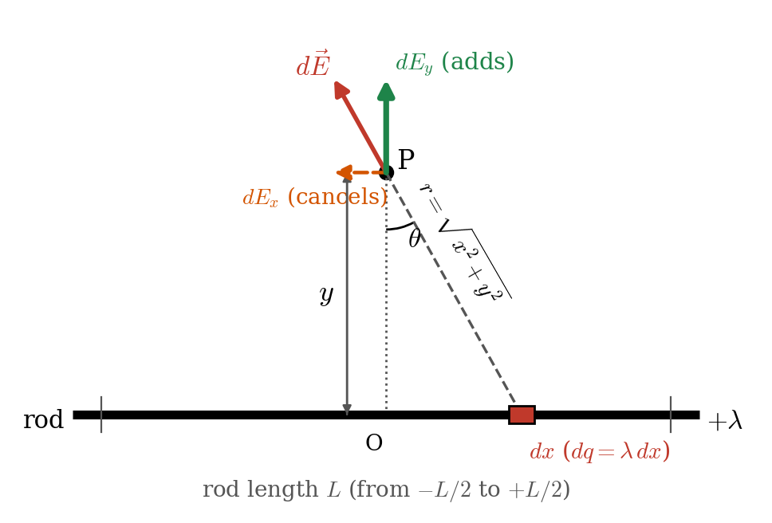
Line (rod) of charge: element $dx$ and its field at point P on the perpendicular bisector.

Derivation
Step 1: field of one element.
$$dE=k\frac{dq}{r^{2}}=k\frac{λ dx}{x^{2}+y^{2}}$$
Step 2: keep only the $y$-component. Let $θ$ be the angle between $PO$ (the perpendicular to the rod) and the line from $dq$ to $P$. Then $cosθ=y/r$ and
$$dE_{y}=dEcosθ=k\frac{λ dx}{x^{2}+y^{2}}⋅\frac{y}{\sqrt{x^{2}+y^{2}}}$$
Step 3: change the variable to angle (this simplifies the integral). Put $x=ytanθ$, so $dx=y\sec^{2}θ dθ$ and $r=ysecθ$:
$$dE_{y}=\frac{kλ}{r^{2}}cosθ dx=\frac{kλcosθ}{y^{2}\sec^{2}θ}⋅y\sec^{2}θ dθ=\frac{kλ}{y}cosθ dθ$$
Step 4: integrate from $−θ_{0}$ to $+θ_{0}$, where $θ_{0}$ is the angle to either end of the rod ($sinθ_{0}=\frac{L/2}{\sqrt{y^{2}+L^{2}/4}}$):
$$E=\frac{kλ}{y}\int_{−θ_{0}}^{+θ_{0}}{cos}θ dθ=\frac{kλ}{y}{\left[sinθ\right]}_{−θ_{0}}^{+θ_{0}}=\frac{2kλsinθ_{0}}{y}$$
Step 5: finite rod result. Substituting $sinθ_{0}$ and $Q=λL$:
$$E_{finite}=\frac{k Q}{y\sqrt{y^{2}+L^{2}/4}} \left(\text{perpendicular to the rod, at the midpoint}\right)$$
Step 6: infinitely long line. When $L→∞$ (or $y≪L$), $θ_{0}→{90}^{∘}$, $sinθ_{0}→1$:
$$E_{∞}=\frac{2kλ}{y}=\frac{λ}{2πε_{0} y} \left(\text{radially outward from the line if }λ>0\right)$$
Alternative check (without angle substitution). $E=kλy\int_{−∞}^{∞}{\frac{dx}{{\left(x^{2}+y^{2}\right)}^{3/2}}}$ and $∫\frac{dx}{{\left(x^{2}+y^{2}\right)}^{3/2}}=\frac{x}{y^{2}\sqrt{x^{2}+y^{2}}}$. Between $−∞$ and $+∞$ this equals $\frac{2}{y^{2}}$, so $E=\frac{2kλ}{y}$, which agrees.

Key points
- Finite rod (at the midpoint): $E=\frac{kQ}{y\sqrt{y^{2}+L^{2}/4}}$.
- Infinite line: $E=\frac{λ}{2πε_{0}y}=\frac{2kλ}{y}$. Falls as $1/y$.
- Field is radial (perpendicular to the line). Components along the line cancel by symmetry.

Deductions and practical concepts
- Far from the rod ($y≫L$): $\sqrt{y^{2}+L^{2}/4}≈y$, so $E→\frac{kQ}{y^{2}}$. The rod looks like a point charge.
- Close to a long rod ($y≪L$) the infinite-line formula is a good approximation if you are away from the ends.
- Pattern of distance dependence. Point charge $∝1/r^{2}$. Infinite line $∝1/r$. Infinite sheet: constant. Dipole $∝1/r^{3}$. Fewer “directions to spread” in space means slower fall-off.
- Cylindrical symmetry. The field has the same magnitude on any cylinder around the line. This is the symmetry exploited by Gauss’s law (Topic 15) to get the same answer in one line.
- Applications: field around a long charged wire or power line, Geiger counter tubes, and wire chambers.
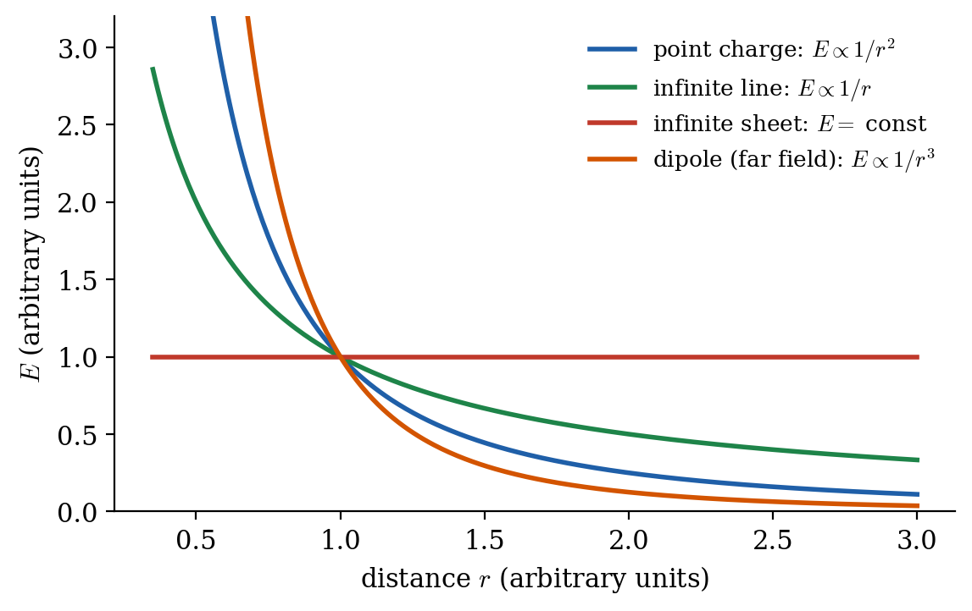
How the field of different sources falls with distance (arbitrary units).

14. Gauss’s Law

Introduction
Gauss’s law is a powerful statement about the electric field and its sources. It relates the total electric flux through any closed surface to the net charge enclosed inside that surface. It is equivalent to Coulomb’s law, but it makes calculations of fields with high symmetry very quick.

Explanation
Think of charge as a source of field lines. Count how many lines pass out through a closed “bag” drawn around some charges. The count depends only on the charge inside the bag, not on the shape or size of the bag, and not on charges outside. Lines from outside charges enter the bag on one side and leave on another, giving net zero.
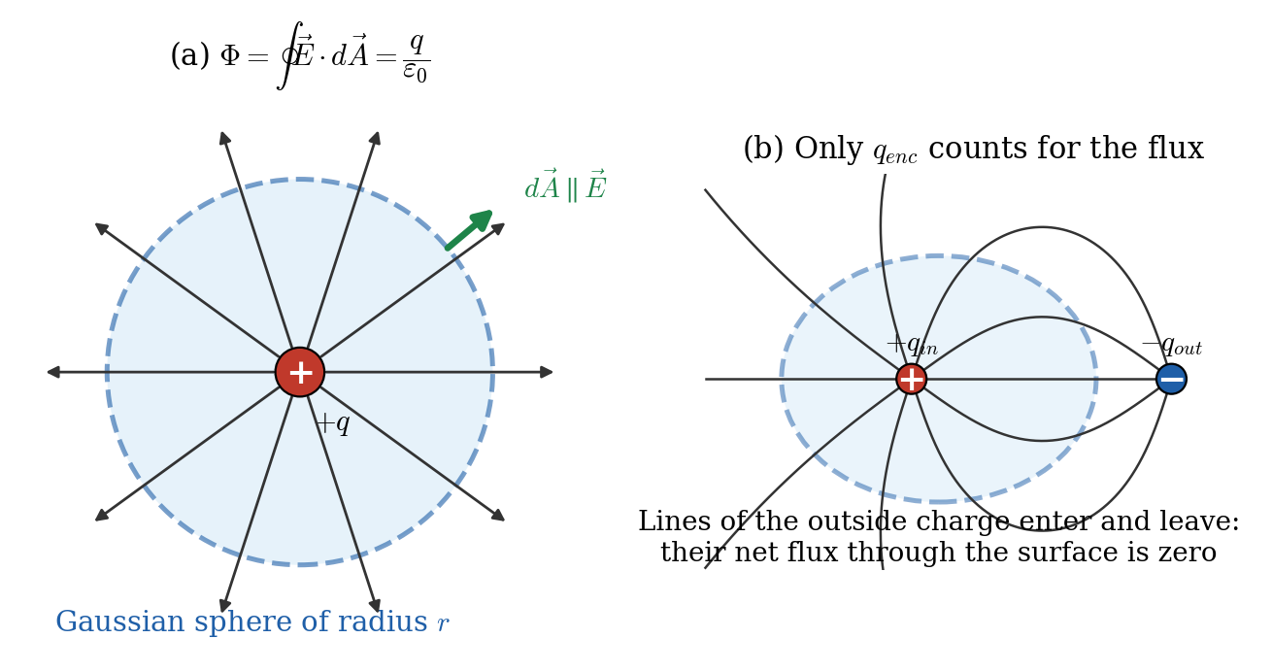
(a) Gaussian sphere around a charge $q$. (b) Charges outside a closed surface give zero net flux through it.

Statement
Gauss’s law: The net electric flux through any closed surface equals the net charge enclosed by the surface divided by $ε_{0}$.
$$Φ_{E}=∮\vec{E}⋅d\vec{A}=\frac{q_{enc}}{ε_{0}}$$
where $q_{enc}=∑q_{inside}$ is the algebraic sum of all charges inside the closed surface (the Gaussian surface), and $\vec{E}$ is the total field at the surface due to all charges (inside and outside).

Consideration (conditions)
- The surface must be closed (a real or imaginary surface with no holes).
- The law is always true, but it is only useful for finding $E$ when the charge distribution has high symmetry (spherical, cylindrical or planar).
- To use it, choose a Gaussian surface such that: (i) $E$ has constant magnitude over the surface (or over parts of it), and (ii) $\vec{E}$ is either parallel ($E dA$) or perpendicular ($E⋅dA=0$) to $d\vec{A}$ on each part. Then $∮\vec{E}⋅d\vec{A}$ becomes simply $E×$ (area).
- The surface should pass through the point where you want the field.

Derivation (from Coulomb’s law)
Step 1: flux through a small patch. Put charge $q$ at the origin and take a small patch $d\vec{A}$ at distance $r$, with its normal making angle $θ$ with the radial direction. The field there is $E=kq/r^{2}$ along $\hat{r}$:
$$dΦ=\vec{E}⋅d\vec{A}=\frac{kq}{r^{2}} dAcosθ=kq \frac{dAcosθ}{r^{2}}=kq dΩ$$
The quantity $dΩ=\frac{dAcosθ}{r^{2}}$ is the solid angle subtended by the patch at the charge. It depends only on direction, not on distance.
Step 2: charge inside. For a closed surface around $q$, the patches together cover all directions, so the total solid angle is $4π$ steradians:
$$Φ=kq∮dΩ=kq \left(4π\right)=\frac{4πq}{4πε_{0}}=\frac{q}{ε_{0}}$$
Step 3: charge outside. A narrow cone of rays from the charge enters the surface through one patch (flux $−kq dΩ$, since $cosθ<0$ for an inward ray) and leaves through another (flux $+kq dΩ$). They cancel, so $Φ=0$.
Step 4: many charges. The field is the vector sum of the fields of all charges (superposition), so the flux is the sum of the individual fluxes. Only charges inside contribute:
$$∮\vec{E}⋅d\vec{A}=\frac{q_{1}+q_{2}+⋯+q_{n}}{ε_{0}}=\frac{q_{enc}}{ε_{0}}$$

Key points
- $∮\vec{E}⋅d\vec{A}=q_{enc}/ε_{0}$ (flux through a closed surface depends only on enclosed charge).
- $\vec{E}$ in the integral is the total field; $q_{enc}$ is only the enclosed charge.
- Use for symmetric charge distributions with a well-chosen Gaussian surface.
- Differential form (Maxwell’s equation): $∇⋅\vec{E}=ρ/ε_{0}$.

Deductions and practical concepts
- Zero net flux does not mean zero field. $Φ=0$ means that equal flux enters and leaves; $\vec{E}$ can be large on the surface (e.g. a dipole inside the surface, or a charge just outside).
- Charges outside change $\vec{E}$ at the surface but not the net flux.
- Moving charges inside the surface (without crossing it) changes the pattern of $\vec{E}$ on the surface but not the total flux.
- Excess charge on a conductor sits on the outer surface. In equilibrium $\vec{E}=0$ inside a conductor, so by Gauss’s law any Gaussian surface drawn inside it encloses zero net charge; all the excess charge must be on the surface.
- Cavity inside a conductor. If the cavity is empty, $E=0$ in it and the cavity wall is uncharged. If a charge $+q$ sits in the cavity, charge $−q$ appears on the cavity wall and $+q$ on the outer surface.
- Link to the inverse-square law. Gauss’s law is true because the force falls as $1/r^{2}$; the $r^{2}$ in the area $4πr^{2}$ cancels it exactly. If the exponent were different, flux would depend on the size of the surface. Faraday’s ice-pail experiment tests this experimentally.
- Gauss’s law (electric) and Faraday’s law are two of Maxwell’s four equations; the electric flux through a closed surface obeys Gauss’s law and magnetic flux through any closed surface is zero (no magnetic monopoles).
- Applications: field of symmetric charge distributions (Topic 15), electrostatic shielding, design of capacitors and coaxial cables.

15. Applications of Gauss’s Law

Introduction
For charge distributions with spherical, cylindrical or planar symmetry, Gauss’s law gives the electric field in a few lines. The recipe is always the same:
- Use symmetry to decide the direction of $\vec{E}$.
- Draw a Gaussian surface with the same symmetry through the point of interest.
- Compute $∮\vec{E}⋅d\vec{A}$ (normally $E×$ area).
- Find $q_{enc}$.
- Solve $E×\text{Area}=q_{enc}/ε_{0}$.
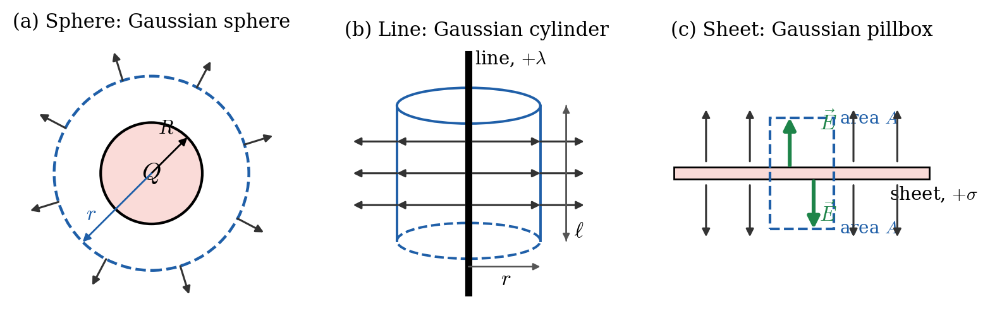
Gaussian surfaces for (a) spherical, (b) cylindrical and (c) planar symmetry.

Application 1: Spherical symmetry (point charge, charged shell, solid sphere)
Gaussian surface: a sphere of radius $r$ concentric with the charge. By symmetry $\vec{E}$ is radial and has the same magnitude everywhere on it, and $\vec{E}∥d\vec{A}$, so
$$∮\vec{E}⋅d\vec{A}=E \left(4πr^{2}\right)$$
(a) Point charge $q$ (or any sphere’s field outside). $q_{enc}=q$:
$$E \left(4πr^{2}\right)=\frac{q}{ε_{0}} ⇒ E=\frac{q}{4πε_{0}r^{2}}=\frac{kq}{r^{2}}$$
This recovers Coulomb’s law.
(b) Thin spherical shell (or conducting sphere) of radius $R$ with total charge $Q$ on its surface.
- Outside ($r>R$): $q_{enc}=Q$, so $E=\frac{kQ}{r^{2}}$.
- Inside ($r<R$): $q_{enc}=0$, so $E=0$.
(c) Solid insulating sphere of radius $R$ with uniform volume charge density $ρ$ and total charge $Q=ρ⋅4/3πR^{3}$.
- Outside ($r≥R$): $E=\frac{kQ}{r^{2}}$.
- Inside ($r<R$): the charge enclosed in radius $r$ is $q_{enc}=ρ⋅4/3πr^{3}=Q\frac{r^{3}}{R^{3}}$. Then
$$E \left(4πr^{2}\right)=\frac{Q r^{3}}{ε_{0}R^{3}} ⇒ E=\frac{Q r}{4πε_{0}R^{3}}=\frac{kQr}{R^{3}}=\frac{ρ r}{3ε_{0}}$$
The field grows linearly from zero at the centre to $kQ/R^{2}$ at the surface, then decreases as $1/r^{2}$.
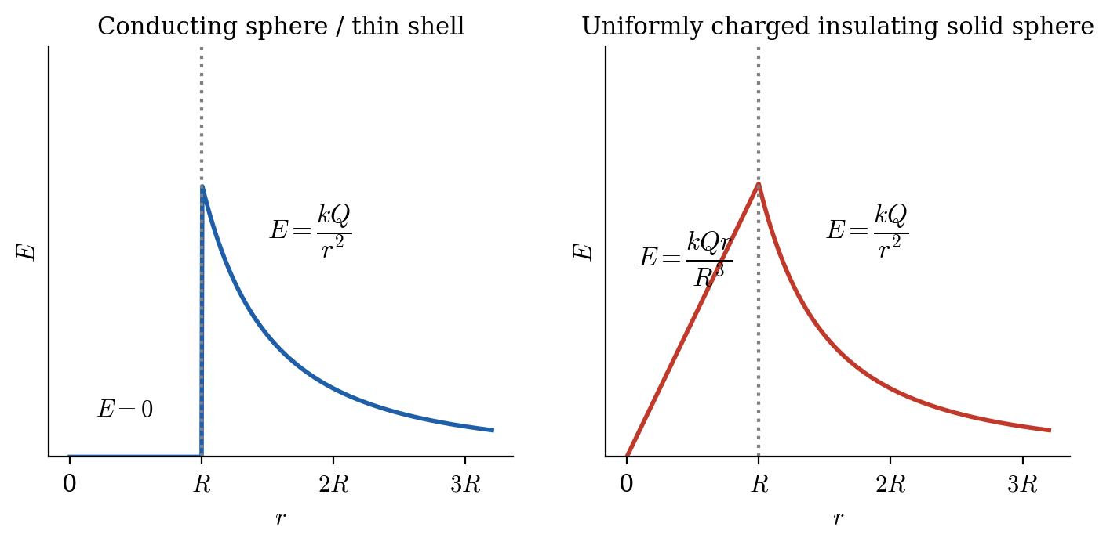
Field versus distance for a charged conducting sphere/shell and for a uniformly charged solid insulating sphere.

Application 2: Infinite line of charge (cylindrical symmetry)
Gaussian surface: a coaxial cylinder of radius $r$ and length $ℓ$. By symmetry, $\vec{E}$ is radial. On the curved surface $\vec{E}∥d\vec{A}$ and $E$ is constant; on the two flat end caps $\vec{E}⊥d\vec{A}$, so they contribute zero flux.
$$∮\vec{E}⋅d\vec{A}=E \left(2πrℓ\right) q_{enc}=λℓ$$
$$E \left(2πrℓ\right)=\frac{λℓ}{ε_{0}} ⇒ \boxed{E=\frac{λ}{2πε_{0} r}=\frac{2kλ}{r}}$$
This agrees with the integration result of Topic 13, in far fewer steps. The same result holds outside a long uniformly charged cylinder (with $λ$ the charge per unit length).

Application 3: Infinite plane sheet of charge (planar symmetry)
Non-conducting sheet with surface charge density $σ$. Gaussian surface: a small pillbox (cylinder) of cross-section area $A$ piercing the sheet, with its two flat faces equidistant from the sheet. By symmetry $\vec{E}$ is perpendicular to the sheet and points away (if $σ>0$). The flux goes out through both end faces and none through the curved side:
$$Φ=EA+EA=2EA q_{enc}=σA$$
$$2EA=\frac{σA}{ε_{0}} ⇒ E=\frac{σ}{2ε_{0}}$$
The field is uniform and independent of distance from the sheet (matches the disk result for $R→∞$).

Application 4: Charged conductor surface
Just outside the surface of a conductor in equilibrium, the field is perpendicular to the surface. Take a pillbox with one face just outside and one face just inside. Inside the conductor $E=0$, so flux passes through the outer face only:
$$EA=\frac{σA}{ε_{0}} ⇒ \boxed{E=\frac{σ}{ε_{0}}}$$
This is twice the field of an isolated non-conducting sheet ($σ/2ε_{0}$). The reason: for a conductor, the sheet’s own field plus the field of all the rest of the conductor’s charges together make $σ/ε_{0}$ outside and cancel inside.

Application 5: Two oppositely charged parallel plates (capacitor)
Each plate (charge density $±σ$) produces $σ/2ε_{0}$. Between the plates the two fields point the same way and add; outside they oppose and cancel:
$$E_{between}=\frac{σ}{2ε_{0}}+\frac{σ}{2ε_{0}}=\frac{σ}{ε_{0}}, E_{outside}=0$$
This uniform field is what a parallel-plate capacitor uses.

Summary table of results
Charge distribution | Gaussian surface | Field
Point charge / sphere (outside) | Sphere | $E=\frac{kQ}{r^{2}}$
Thin shell, inside | Sphere | $E=0$
Solid insulating sphere, inside | Sphere | $E=\frac{kQr}{R^{3}}=\frac{ρr}{3ε_{0}}$
Infinite line | Coaxial cylinder | $E=\frac{λ}{2πε_{0}r}$
Infinite non-conducting sheet | Pillbox | $E=\frac{σ}{2ε_{0}}$
Conductor surface (just outside) | Pillbox | $E=\frac{σ}{ε_{0}}$
Two opposite plates | Pillbox | $E=\frac{σ}{ε_{0}}$ (between), $0$ (outside)

Key points
- Recipe: symmetry $→$ Gaussian surface $→$ $∮\vec{E}⋅d\vec{A}→q_{enc}→E$.
- Sphere: $E=kQ/r^{2}$ outside; $0$ inside a shell; $∝r$ inside a uniform solid sphere.
- Line: $E∝1/r$. Sheet: $E=σ/2ε_{0}$ (constant). Conductor: $σ/ε_{0}$.

Deductions and practical concepts
- Shell theorem for fields. Outside any spherically symmetric charge the field is that of a point charge at the centre. Inside a shell there is no field.
- Why zero field inside a hollow conductor? Excess charge sits on the outer surface; the Gaussian surface inside encloses no charge, so $E=0$ throughout the cavity. This is electrostatic shielding.
- Field is continuous or discontinuous? For a solid charged sphere the field is continuous at the surface. For a thin shell it jumps by $σ/ε_{0}$ at the surface (from 0 to $kQ/R^{2}$).
- Why a sheet’s field does not fall with distance. The field lines do not spread out (the sheet is infinite, so lines stay parallel). Real plates behave like this only when the distance is much smaller than the plate size.
- Gaussian surface is imaginary. It does not have to coincide with a real surface. Choose its radius at will.
- Gauss’s law cannot be used to find the field of a finite rod, finite disk, ring or dipole by itself, because they lack enough symmetry; use direct integration instead (Topics 10 to 13).
- Applications: coaxial cables, Geiger counters, capacitors (parallel-plate, spherical, cylindrical), shielding of sensitive instruments and lightning rods.

16. Electric Potential

Introduction
The electric field is a vector, which makes it complicated to add. A simpler way to describe the electric effect of charges is with electric potential, a scalar quantity. It tells us the electrical potential energy per unit charge at a point.

Explanation
Compare with gravity: an object has more gravitational potential energy higher up a hill. Electric potential is the same idea: a positive charge has more potential energy at a higher potential and will move “downhill” to lower potential. The potential difference (voltage) between two points is what drives current in circuits.
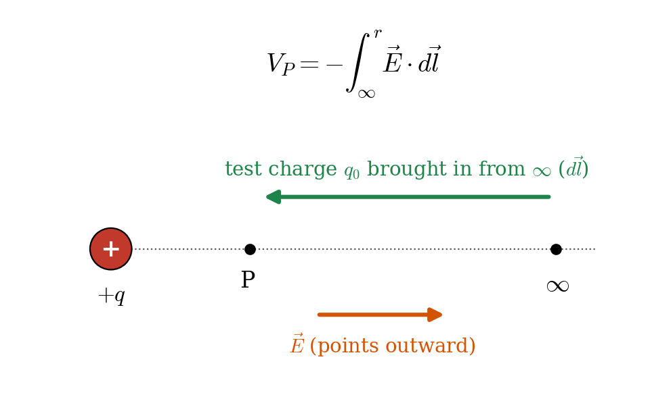
Potential at a point P: the work per unit charge to bring a positive test charge from infinity to P.

Definition
Electric potential at a point is the work done per unit positive charge by an external agent in bringing a test charge slowly from infinity (reference point, $V=0$) to that point:
$$V=\frac{U}{q_{0}}=\frac{W_{∞→P}}{q_{0}}$$
Potential difference between points $A$ and $B$ is the work per unit charge needed to move a test charge from $A$ to $B$ (equal to the negative of the work done by the field):
$$ΔV=V_{B}−V_{A}=\frac{ΔU}{q_{0}}=−\int_{A}^{B}{\vec{E}}⋅d\vec{l}$$
Unit: volt, $1 \text{V}=1 \text{J/C}$. Also $1 \text{N/C}=1 \text{V/m}$.

Derivation: relation between $E$ and $V$
Step 1. Work done by the electric field to move a test charge $q_{0}$ through displacement $d\vec{l}$: $dW=\vec{F}⋅d\vec{l}=q_{0}\vec{E}⋅d\vec{l}$.
Step 2. The change in potential energy is the negative of this work: $dU=−q_{0}\vec{E}⋅d\vec{l}$. Dividing by $q_{0}$:
$$dV=−\vec{E}⋅d\vec{l}$$
Step 3. Integrate from $A$ to $B$:
$$V_{B}−V_{A}=−\int_{A}^{B}{\vec{E}}⋅d\vec{l}$$
Step 4: the reverse relation. Taking a small step $dx$ along $x$: $dV=−E_{x} dx$, so
$$E_{x}=−\frac{dV}{dx}, \vec{E}=−∇V=−\left(\frac{∂V}{∂x}\hat{i}+\frac{∂V}{∂y}\hat{j}+\frac{∂V}{∂z}\hat{k}\right)$$
In words: the field points in the direction in which the potential decreases most rapidly, and its size equals the rate of change of potential with distance.
Special case: uniform field. Move a distance $d$ along the field. Then $\vec{E}⋅d\vec{l}=E dl$, so
$$V_{B}−V_{A}=−Ed \text{or} E=\frac{\left|ΔV\right|}{d}$$
Potential decreases along the field, by $Ed$ over a distance $d$ (parallel plates: $E=V/d$).

Superposition
Potential is a scalar, so the potential of many charges is the algebraic sum (with signs):
V=i​Vi=ki​qiri

Key points
- $V=U/q_{0}$ (J/C = volt). Scalar. Reference: $V\left(∞\right)=0$.
- $ΔV=−∫\vec{E}⋅d\vec{l}$ and $\vec{E}=−∇V$ ($E_{x}=−dV/dx$).
- Positive charges move spontaneously from high to low $V$; negative charges from low to high $V$.
- Uniform field: $ΔV=−Ed$.
- Work done by the field: $W=q\left(V_{A}−V_{B}\right)$.

Deductions and practical concepts
- $E=0$ does not mean $V=0$. Examples: the centre of a charged ring ($E=0$ but $V=kQ/R$); inside a charged conductor ($E=0$ but $V$ is a constant, non-zero value).
- $V=0$ does not mean $E=0$. Example: the equatorial plane of a dipole has $V=0$ but $E≠0$.
- Where $V$ is constant, $E=0$ along that direction; where $V$ changes rapidly with distance, $E$ is large.
- Energy gain. A charge $q$ moving through a potential difference $ΔV$ gains kinetic energy $ΔK=q ΔV$. For a charge starting from rest, $1/2mv^{2}=q ΔV$ so $v=\sqrt{2qΔV/m}$. An electron accelerated through 1 V gains 1 eV $=1.602×{10}^{−19}$ J.
- Electrostatic field is conservative. The work done between two points does not depend on the path, so $∮\vec{E}⋅d\vec{l}=0$ for a closed path.
- Potential difference matters, not absolute potential. Only differences have physical meaning; we pick a convenient zero (infinity or the Earth).
- Applications: batteries ($ΔV$ between terminals), voltmeters, capacitors, electron guns, ECG and EEG (potential differences on the body), and bird safety on power lines (the bird sits at a single potential).

17. Electric Potential Energy

Introduction
When charges interact, the system stores energy depending on how the charges are arranged. This is the electric potential energy $U$: the energy stored because of the positions of charges. It is the electrical analogue of gravitational potential energy.

Explanation
To push two like charges closer, we must do work against their repulsion. That work is stored in the system as potential energy; if released, the charges fly apart and the energy turns into kinetic energy. For opposite charges it is the reverse: work is needed to separate them.

Definition
Change in potential energy equals the negative of the work done by the electric force when the configuration changes:
$$ΔU=U_{B}−U_{A}=−W_{A→B}^{\left(field\right)}=+W_{A→B}^{\left(external\right)}$$
Potential energy of a charge at a point is defined relative to infinity ($U=0$ when infinitely far apart): $U$ is the work done by an external agent in bringing the charge slowly from infinity to that point.

Derivation: potential energy of two point charges
Setup. Charge $q_{1}$ is fixed at the origin. Bring charge $q_{2}$ slowly from infinity to a distance $r$ along a radial line.
Step 1: forces. The electric force on $q_{2}$ is $F_{e}=\frac{kq_{1}q_{2}}{r′^{2}}$ (outward for like charges). The external agent must exert an equal and opposite force, $F_{ext}=−F_{e}$, so the charge moves without acceleration.
Step 2: work done by the external agent (the displacement is inward, from $∞$ to $r$):
$$W_{ext}=\int_{∞}^{r}{{\vec{F}}_{ext}}⋅d\vec{r}′=−\int_{∞}^{r}{\frac{kq_{1}q_{2}}{r′^{2}}} dr′=−kq_{1}q_{2}{\left[−\frac{1}{r′}\right]}_{∞}^{r}=\frac{kq_{1}q_{2}}{r}$$
Step 3: this work is stored as potential energy:
$$U=\frac{1}{4πε_{0}}\frac{q_{1}q_{2}}{r}=k\frac{q_{1}q_{2}}{r}$$
The signs of $q_{1},q_{2}$ are included: $U>0$ for like charges, $U<0$ for unlike charges.

System of more than two charges
Add the energy of every pair (each pair counted once):
U=ki<j​qiqjrij
For three charges: $U=k\left[\frac{q_{1}q_{2}}{r_{12}}+\frac{q_{1}q_{3}}{r_{13}}+\frac{q_{2}q_{3}}{r_{23}}\right]$. This equals the work needed to assemble the charges from infinity.

Relation with potential and force
$$U=q V, ΔU=q ΔV, F=−\frac{dU}{dr}$$
In a uniform field. Moving a charge $q$ a distance $d$ along the field changes its potential energy by $ΔU=−qEd$ (decreases for positive $q$ moving along $\vec{E}$).
Conservation of energy (only electric forces acting):
$$K_{A}+U_{A}=K_{B}+U_{B} ⇒ 1/2mv_{A}^{2}+qV_{A}=1/2mv_{B}^{2}+qV_{B}$$

Key points
- $U=k\frac{q_{1}q_{2}}{r}$ for two charges ($U=0$ at $r=∞$); $U=qV$.
- Like charges: $U>0$ (repel). Unlike charges: $U<0$ (bound).
- Many charges: sum over all pairs: U=ki<j​qiqj/rij.
- $ΔU=−W_{field}$; $F=−dU/dr$; $K+U=$ constant.
- Unit: joule; atomic scale: electron-volt (1 eV $=1.602×{10}^{−19}$ J).

Deductions and practical concepts
- Sign tells the story. $U>0$: work has to be done to bring the charges together, and they will separate if free. $U<0$: the charges are bound, and energy must be supplied to pull them apart. The magnitude $\left|U\right|$ of a negative $U$ is the binding energy at that separation.
- Hydrogen atom. For an electron and proton at $r=0.529×{10}^{−10}$ m: $U=−\frac{ke^{2}}{r}=−27.2$ eV and kinetic energy $K=+13.6$ eV, so total energy $=−13.6$ eV. The ionization energy of hydrogen is 13.6 eV.
- Closest approach (Rutherford). A charge $q$ with kinetic energy $K$ fired head-on at a fixed charge $Q$ stops at $r_{min}$ where $K=\frac{kQq}{r_{min}}$, so $r_{min}=\frac{kQq}{K}$.
- Escape. A system with total energy $K+U≥0$ is unbound. If $<0$ the particles stay together.
- Energy in a dipole. A dipole in a uniform field has $U=−\vec{p}⋅\vec{E}$ (Topic 9), the sum of the energies of its two charges.
- The reference point is arbitrary; only differences $ΔU$ matter physically.
- Applications: nuclear fission (electrical repulsion of fragments releases about 200 MeV), chemical bonds, capacitor energy storage, ion engines and particle accelerators.

18. Electric Potential Due to a Point Charge

Introduction
We now find the potential $V$ at distance $r$ from a single point charge $q$. This is the most important potential formula, because the potential of any group of charges is built from it by superposition.

Consideration (setup and assumptions)
- Source charge $q$ at the origin. Field point $P$ at distance $r$.
- Reference point: $V\left(∞\right)=0$.
- Since the electrostatic field is conservative, we may choose any path from infinity to $P$. We choose a straight radial line, along which $\vec{E}$ and $d\vec{l}$ are parallel (or antiparallel).

Derivation
Step 1: start from the definition.
$$V\left(r\right)−V\left(∞\right)=−\int_{∞}^{r}{\vec{E}}⋅d\vec{l}$$
Step 2: substitute the field of a point charge, $E=\frac{kq}{r′^{2}}$ along $\hat{r}$. Write the radial displacement as $d\vec{l}=dr′ \hat{r}$, with $r′$ running from $∞$ to $r$, so $\vec{E}⋅d\vec{l}=E dr′$ (the direction of travel is carried by the limits):
$$V\left(r\right)=−\int_{∞}^{r}{\frac{kq}{r′^{2}}} dr′$$
Step 3: integrate. $∫\frac{dr′}{r′^{2}}=−\frac{1}{r′}$:
$$V\left(r\right)=−kq{\left[−\frac{1}{r′}\right]}_{∞}^{r}=kq\left[\frac{1}{r}−\frac{1}{∞}\right]=\frac{kq}{r}$$
$$V=\frac{1}{4πε_{0}}\frac{q}{r}=\frac{kq}{r}$$
Step 4: check. $E=−\frac{dV}{dr}=−\frac{d}{dr}\left(\frac{kq}{r}\right)=\frac{kq}{r^{2}}$ ✓.
Group of point charges (superposition, scalar sum):
V=ki​qiri

Extensions (important results)
Dipole (far field, $r≫a$). At a point $\left(r,θ\right)$, the distances to $±q$ are $r_{±}≈r∓acosθ$:
$$V=kq\left(\frac{1}{r_{+}}−\frac{1}{r_{−}}\right)=kq \frac{2acosθ}{r^{2}}=\frac{kpcosθ}{r^{2}}$$
On the equatorial plane ($θ={90}^{∘}$), $V=0$.
Ring, on the axis. All elements are at distance $\sqrt{x^{2}+R^{2}}$:
$$V=\frac{kQ}{\sqrt{x^{2}+R^{2}}}$$
Charged conducting sphere or thin shell (radius $R$, charge $Q$).
$$V=\frac{kQ}{r} \left(r≥R\right), V=\frac{kQ}{R}=\text{constant} \left(r≤R\right)$$

Key points
- $V=\frac{kq}{r}$ with $V\left(∞\right)=0$. Sign of $V$ = sign of $q$.
- $V∝1/r$ (while $E∝1/r^{2}$). $E=−dV/dr$.
- Many charges: $V=k∑q_{i}/r_{i}$ (algebraic sum).
- Work to move $q_{0}$ from $A$ to $B$ in the field of $q$: $W=q_{0} kq\left(\frac{1}{r_{B}}−\frac{1}{r_{A}}\right)$.

Deductions and practical concepts
- Positive charge: $V>0$ and decreases with distance. Negative charge: $V<0$ and rises toward zero at infinity.
- Potential is a scalar so there are no components to resolve. To get $V$ of many charges you simply add numbers, which is much easier than adding field vectors.
- Surfaces of constant $r$ have constant $V$, which are concentric spheres: the equipotential surfaces (Topic 19).
- Conductor. All points of a conducting sphere (inside and on the surface) are at potential $kQ/R$. Charge flows from a higher-potential body to a lower-potential one when connected.
- Charge sharing. When two spheres are connected by a wire, charge flows until their potentials are equal, so the sphere with the larger radius ends with the larger charge.
- Electron-volt and speed. An electron accelerated from rest through $V$ gains $eV$: $v=\sqrt{2eV/m_{e}}$.
- Applications: potential of the Earth taken as zero for circuits, Van de Graaff generators, particle detectors, and the field of ionic crystals.

19. Equipotential Surfaces

Introduction
An equipotential surface is a surface (or line in 2D) on which every point is at the same electric potential. They are the electrical equivalent of contour lines on a map: points on the same contour line are at the same height.

Explanation
If a charge moves along an equipotential surface, its potential energy does not change ($ΔV=0$), so the electric field does no work on it. Equipotential surfaces are drawn at equal steps of potential (e.g. 10 V, 20 V, 30 V), and they give a second way of mapping a field, together with the field lines.
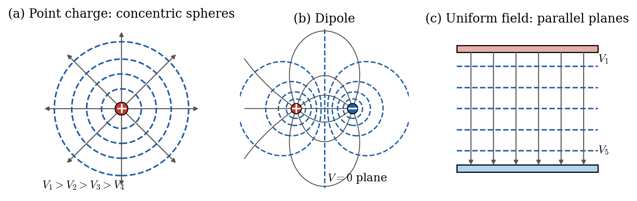
Equipotential surfaces (dashed) and field lines (solid): (a) point charge, (b) dipole, (c) uniform field.

Properties of equipotential surfaces
- No work is done in moving a charge between two points on the same equipotential surface.
- The electric field is always perpendicular to the equipotential surface at every point.
- Two equipotential surfaces never intersect, because a point cannot have two potentials.
- The field points from higher to lower potential.
- Where equipotential surfaces are close together, the field is strong; where far apart, it is weak.
- The surface of a conductor in equilibrium is an equipotential surface, and so is the whole body of the conductor.

Proofs and derivations
Proof that $\vec{E}⊥$ surface. Let $d\vec{l}$ be a small displacement along the equipotential surface. Then $dV=0$, so
$$dV=−\vec{E}⋅d\vec{l}=−E dlcosϕ=0 ⇒ cosϕ=0 ⇒ ϕ={90}^{∘}$$
so $\vec{E}$ is perpendicular to every possible displacement along the surface, i.e. perpendicular to the surface.
Spacing and field strength. Take two equipotential surfaces with potentials $V$ and $V+dV$ separated by a perpendicular distance $dn$. Then
$$E=−\frac{dV}{dn} ⇒ \left|E\right|=\frac{\left|dV\right|}{dn}$$
For equal steps $\left|dV\right|$, a smaller spacing $dn$ means a larger $E$.

Shapes in common cases
Source of field | Equipotential surfaces | Notes
Point charge $q$ | Concentric spheres, $r=kq/V$ | Spacing grows with $r$ for equal $ΔV$ (since $E∝1/r^{2}$)
Uniform field $\vec{E}$ | Equally spaced parallel planes, $⊥\vec{E}$ | $ΔV=E d$ between planes
Infinite line of charge | Coaxial cylinders | $V=−\frac{λ}{2πε_{0}}lnr+C$
Electric dipole | Rounded surfaces around each charge; $V=0$ plane in the middle | Shape of figure (b)
Charged conductor | Parallel to the surface | Surface itself is an equipotential
For a point charge, the spacing between equally spaced potentials: $r_{n}=\frac{kq}{V_{n}}$, e.g. for $V=10,20,30$ V the radii are in the ratio $1:1/2:1/3$, so the surfaces get closer to the charge, showing that the field is stronger there.

Key points
- Equipotential: $V=$ constant, so $ΔV=0$ and $W=0$ along it.
- $\vec{E}⊥$ equipotential, always, and $\vec{E}$ points toward lower $V$.
- Never intersect. Closer spacing means stronger field: $E=−dV/dn$.
- Conductor surface and volume: one equipotential. Point charge: spheres. Uniform field: parallel planes.

Deductions and practical concepts
- Field lines and equipotentials form a grid of mutually perpendicular curves, like the lines of latitude and the lines of a compass.
- Why no work? The force $q\vec{E}$ is perpendicular to the displacement along the surface, so $W=\vec{F}⋅d\vec{l}=0$.
- Why a conductor is an equipotential. If two points on a conductor differed in potential, there would be an internal field and charges would flow until the difference vanished. So in electrostatic equilibrium the conductor is at one potential.
- Consequence: field lines meet conductors at 90°, and the field is strongest at sharp points where equipotentials crowd together, which is why lightning rods work.
- Shielding. A closed hollow conductor shields its interior: the cavity is at a single potential, so there is no field (Faraday cage; a car or aeroplane protects from lightning).
- Mapping fields. In an experiment, an equipotential is found by moving a voltmeter probe so that it reads a constant value; field lines are then drawn perpendicular to these.
- Safety. Near a lightning strike the ground has potential differences between your feet; keeping your feet together keeps them on one equipotential and reduces the risk (step voltage).
- Direction of motion. A free positive charge moves toward lower potential (along $\vec{E}$, crossing equipotentials at right angles); a negative charge moves toward higher potential.

20. Master Revision Sheet

All standard formulas in one place
Topic | Formula
Faraday’s law | $ε=−N\frac{dΦ_{B}}{dt}$; $Φ_{B}=BAcosθ$; $ε=Blv$
Quantization of charge | $Q=±ne$
Coulomb’s law | $F=k\frac{q_{1}q_{2}}{r^{2}}$, $k=\frac{1}{4πε_{0}}$; ${\vec{F}}_{12}=k\frac{q_{1}q_{2}}{r^{2}}{\hat{r}}_{12}$
Electric field (definition) | $\vec{E}=\vec{F}/q_{0}$; $\vec{F}=q\vec{E}$
Point charge field | $E=\frac{kq}{r^{2}}$
Electric flux | $Φ_{E}=\vec{E}⋅\vec{A}=EAcosθ$; $Φ_{E}=∮\vec{E}⋅d\vec{A}$
Dipole moment | $\vec{p}=q\left(2\vec{a}\right)$; $τ=pEsinθ$; $U=−\vec{p}⋅\vec{E}$
Dipole field, axial | $E=\frac{2kpr}{{\left(r^{2}−a^{2}\right)}^{2}}≈\frac{2kp}{r^{3}}$
Dipole field, equatorial | $E=\frac{kp}{{\left(r^{2}+a^{2}\right)}^{3/2}}≈\frac{kp}{r^{3}}$
Ring (axis) | $E=\frac{kQx}{{\left(x^{2}+R^{2}\right)}^{3/2}}$
Disk (axis) | $E=\frac{σ}{2ε_{0}}\left[1−\frac{x}{\sqrt{x^{2}+R^{2}}}\right]$
Infinite line | $E=\frac{λ}{2πε_{0}y}$
Finite rod (bisector) | $E=\frac{kQ}{y\sqrt{y^{2}+L^{2}/4}}$
Gauss’s law | $∮\vec{E}⋅d\vec{A}=\frac{q_{enc}}{ε_{0}}$
Infinite sheet | $E=\frac{σ}{2ε_{0}}$
Conductor surface | $E=\frac{σ}{ε_{0}}$
Shell, inside / outside | $0$ / $\frac{kQ}{r^{2}}$
Uniform solid sphere, inside | $E=\frac{kQr}{R^{3}}$
Potential difference | $ΔV=−∫\vec{E}⋅d\vec{l}$; $\vec{E}=−∇V$
Uniform field | $ΔV=−Ed$
Point-charge potential | $V=\frac{kq}{r}$
Dipole potential | $V=\frac{kpcosθ}{r^{2}}$
Potential energy (2 charges) | $U=\frac{kq_{1}q_{2}}{r}$; $U=qV$
Many charges | $V=k∑\frac{q_{i}}{r_{i}}$; U=ki<j​qiqjrij

How the fields fall off with distance
Source | Dependence | Reason
Point charge | $E∝1/r^{2}$ | Lines spread over a sphere $4πr^{2}$
Infinite line | $E∝1/r$ | Lines spread over a cylinder $2πrℓ$
Infinite sheet | $E=$ constant | Lines do not spread
Electric dipole (far field) | $E∝1/r^{3}$ | Two nearly cancelling charges
Ring / disk / finite rod (far field) | $E→kQ/r^{2}$ | Look like a point charge from far away

Common exam mistakes to avoid
- Mixing up $r$ and $r±a$ in dipole problems. Distances are measured from each charge, then converted to $r$ from the centre.
- Forgetting that $E$ is a vector. Resolve into components and cancel by symmetry before integrating.
- Using the signs of charges in the magnitude of Coulomb force. Use signs only to decide the direction.
- Confusing $Φ=0$ with $E=0$, and $E=0$ with $V=0$.
- Writing $∮\vec{E}⋅d\vec{A}=q/ε_{0}$ with $q$ as all charges; it is the enclosed charge only.
- Using $σ/2ε_{0}$ for a conductor. Just outside a conductor $E=σ/ε_{0}$.
- Using $θ$ as the angle with the surface instead of the normal in $Φ=EAcosθ$.
- Forgetting $k$ versus $ε_{0}$: $k=1/4πε_{0}$; do not use both in one formula.
- Forgetting the minus sign in $\vec{E}=−∇V$ and in Lenz’s law.
- Not stating assumptions (point charges, vacuum, $r≫a$) before a derivation.

How to write a derivation in the exam
- Draw a clear, labelled diagram. 2. State the setup and assumptions. 3. Write the law you apply (Coulomb or Gauss). 4. Write the small element or the surface and use symmetry. 5. Integrate showing the substitution. 6. Write the final boxed result and state its direction. 7. Add the special cases (far field, limiting case), because that is where marks are often awarded.

